CHAPTER ONE

INTRODUCTION

1.1 Background of the Study
In the modern institutional and corporate ecosystem, the management of physical assets and the governance of material procurement have evolved from administrative peripheral tasks into fundamental drivers of organizational competitiveness and operational resilience. Asset-intensive organizations rely on the seamless coordination of inventory records and requisition approvals to ensure that the right resources reach the right personnel at the right time. Any failure within this chain, whether caused by human error, data inconsistency, or procedural opacity, can cascade into measurable financial losses, compliance violations, and productivity setbacks(K R et al., 2025).
Historically, inventory management and procurement workflows were handled through manual methods: handwritten ledgers, physical requisition forms, and verbal communications between departments. Although these approaches were adequate for small-scale operations, they proved fundamentally inadequate as organizations expanded, diversified their workforce, and adopted multi-branch structures. The limitations of paper-based systems became strikingly apparent during periods of high transaction volume, where the absence of real-time visibility and centralized control led to chronic inefficiencies such as stock discrepancies, unauthorized withdrawals, and delayed approvals that stalled operational continuity(Al-Kahtani, M. S., & Al-Ghamdi, 2021).
The evolution of web technologies has facilitated a paradigm shift from these isolated legacy systems toward centralized, browser-accessible platforms. In this modern framework, the user interface has transitioned from simple form-based data entry into interactive digital storefronts that allow employees to browse available inventory items in a manner analogous to commercial e-commerce platforms. Rather than employees guessing at stock availability or waiting days for confirmation, they can view live inventory counts, filter items by category or department, and submit digital requisitions that are automatically routed for approval, all within a single web application(-, 2024).
Central to these modern systems is the approval workflow, a rule-based process that routes requests through a sequence of predefined approvers using automation logic. Conventional approval processes are characterized by excessive communication overhead, where requisitions bounce between email threads, physical desk trays, and verbal handoffs over the course of several business days. Automated workflow engines address these inefficiencies by enforcing deterministic routing logic, providing real-time status updates, and eliminating the possibility of a requisition being “lost” in someone’s inbox(Holloway, 2024).
Furthermore, the implementation of Role-Based Access Control (RBAC) ensures that these systems operate on the Principle of Least Privilege (PoLP). RBAC maps permissions to organizational roles rather than to individual identities. This approach not only simplifies access administration but also enforces clear boundaries of authority within the system: an employee with a standard user role can submit and track requisitions but cannot approve them or modify inventory records. This separation of duties prevents unauthorized actions, reduces the attack surface for insider threats, and provides auditors with a coherent, verifiable record of every system interaction(Rostami, 2023).
This study is inspired by, and situated within, the operational context of the Cocoa Marketing Company (Ghana) Limited (CMC), the marketing subsidiary of the Ghana Cocoa Board (COCOBOD) responsible for the sale and export of Ghana’s cocoa beans and cocoa products. Like many large public-sector institutions in Ghana, CMC coordinates inventory and internal requisitions across a head office and outstation operations, involving multiple departments and layers of approval authority. Observations of current practice reveal a heavy dependence on paper requisition forms, spreadsheet-based stock records, and manual, signature-driven approval chains. These practices give rise to approval delays, weak audit trails, stock records that do not reflect physical reality, and limited controls over who may view or modify sensitive inventory data.
By designing and implementing a Web-Based Inventory and Requisition Management System grounded in the requirements of an organization such as CMC, this project aims to deliver a practical solution that directly addresses these deficiencies. The system integrates real-time inventory visibility, a multi-role approval workflow, and comprehensive audit logging within a single web application, thereby bridging the gap between enterprise software engineering theory and practical deployment in a resource-constrained organizational environment(Al-Kahtani, M. S., & Al-Ghamdi, 2021).

1.2 Problem Statement
Despite the widespread availability of advanced software solutions, a significant proportion of businesses, estimated at approximately 41% by industry surveys, still rely on manual processes for logging and managing their inventory. This reliance on legacy methods creates a cluster of interrelated operational and security problems that collectively undermine organizational efficiency, financial accountability, and regulatory compliance.
The specific problems addressed by this study include the following:
- Approval Latency and Lack of Status Visibility: In manual systems, purchase orders and requisition forms often bounce between email threads, physical desk trays, and informal verbal handoffs. This decentralized approach means that a single absent approver, whether out of the office or overwhelmed with other duties, can stall an entire procurement cycle for two to five business days. Employees who submit requisitions have no reliable mechanism for tracking their request status in real time, leading to repeated follow-up calls and emails that consume productive work hours and generate frustration across all stakeholders.
- Accountability and Audit Risks: Verbal approvals and paper signatures are notoriously difficult to verify and are frequently challenged during internal and external audits. A common pain point occurs when key personnel temporarily delegate their authority verbally during absence; audit investigators subsequently find it impossible to attribute specific approval decisions to named individuals. This lack of a verifiable audit trail exposes organizations to regulatory penalties, increases the cost of compliance exercises, and creates opportunities for fraud through plausible deniability.
- Data Inconsistency and Phantom Stock: Manual tracking fails to provide real-time data currency. When stock levels are not updated instantaneously upon each transaction, stale records persist in spreadsheets. These phantom stock records lead to situations where employees submit requisitions for items that are physically out of stock, causing downstream confusion, wasted administrative effort, and project delays. Conversely, items may appear consumed in the records when they are actually present in the warehouse, leading to unnecessary procurement and budget overspending.
- Security and Unauthorized Access: Without a formal RBAC framework, sensitive inventory and procurement records are frequently over-exposed to individuals who lack legitimate business need. The prevalent "everyone is an admin" anti-pattern in spreadsheet-based systems allows any user with file access to modify stock quantities, delete transaction records, or view confidential financial data. This creates significant risks of insider fraud and data integrity violations that are difficult or impossible to detect without comprehensive access logging.
- Concurrency and Race Conditions: In multi-user environments where several staff members access the same inventory records simultaneously, naive "read-then-write" database operations introduce the risk of Time-of-Check-to-Time-of-Use (TOCTOU) race conditions. If two users independently read a stock count of one remaining unit and both proceed to reserve that unit, the result is a double-allocation error: both users believe they have secured the item, but only one physical unit is available. This class of software bugs, if unaddressed, leads to operational conflicts and inventory discrepancies that erode trust in the system.
This project directly addresses these critical gaps by designing and implementing a web-based system that integrates a distributed architecture with a robust multi-step approval matrix, ensuring every requisition is tracked, authorized, and fulfilled through a secure, auditable, and conflict-free digital process.

1.3 Aim of the Study
The primary aim of this study is to design and implement a Web-Based Inventory and Requisition Management System for the Cocoa Marketing Company that automates the complete lifecycle of an inventory requisition. In achieving this aim, the system seeks to provide staff of the organization with a unified platform that improves transparency, accelerates decision-making, and enforces governance standards consistently across all branches and departments.

1.4 Objectives of the Study
To achieve the stated aim, the following specific objectives will be pursued:
- To analyse the existing manual inventory and requisition processes of the Cocoa Marketing Company and identify their operational, security, and accountability weaknesses.
- To design a centralized, web-based inventory system that gives authorized staff real-time visibility of stock levels across the head office and branch warehouses.
- To develop a role-based requisition module in which submitted requests are automatically routed through the appropriate approval hierarchy, covering the Head of Department, IT Manager, Account, and Account Manager levels as applicable.
- To implement security and accountability controls, including role-based access control, separation of duties, and an append-only audit trail of all approvals and stock movements.
- To safeguard data integrity under concurrent multi-user access through atomic database transactions that prevent the double allocation of stock.
- To test and evaluate the developed system against the functional and non-functional requirements identified during the system analysis phase.

1.5 Research Questions
This study seeks to answer the following research questions:
- How can real-time inventory visibility reduce phantom stock requests and reconciliation errors within the organization’s procurement processes?
- To what extent can automated workflow routing reduce approval cycle times for departmental requisitions compared to paper-based and email-based approval flows?
- How effective are role-based access control and separation of duties constraints in preventing unauthorized requisition approvals within a multi-branch, multi-role organization?
- How can atomic database update strategies mitigate the risks of race conditions in a multi-user inventory management system?
- In what ways does centralized audit logging improve the organization’s readiness for internal and external compliance audits compared to manual record-keeping?

1.6 Significance of the Study
This study provides significant value to multiple stakeholders within an organization as well as to the broader academic and professional community engaged in enterprise software development and information systems research. The significance is articulated at several levels:

Organization
The system enhances organizational productivity and operational efficiency by removing the communication overhead and administrative friction that characterize manual approval processes. By reducing approval cycle times from an average of two to five business days to a target of under twenty-four hours, the organization gains a measurable competitive advantage in the speed and reliability of its internal resource distribution. The elimination of phantom stock records and double-allocation errors directly reduces procurement costs and minimizes the financial losses associated with inventory shrinkage.

Management
Senior management and department heads gain access to real-time dashboards that provide granular visibility into consumption patterns, pending approvals, departmental spending trends, and stock depletion trajectories. This data-driven intelligence enables more informed budgetary decisions, proactive resource planning, and timely intervention when unusual procurement patterns, possibly indicative of fraud or misuse, are detected. The centralized approval matrix also ensures that management maintains clear, documented authority over procurement decisions at every level of the organizational hierarchy.

Auditors and Compliance Officers
The system ensures audit readiness by maintaining a retrievable, tamper-evident record of every transaction, approval decision, and delegation event. The append-only audit log table structure means that historical records cannot be modified or deleted without a clearly traceable administrative action. This dramatically reduces the cost and duration of internal and external compliance exercises, as auditors can retrieve complete transaction histories through a structured query interface rather than manually reconstructing approval chains from email archives and paper files. The system also directly supports compliance with regulatory frameworks that mandate segregation of duties and documented approval evidence.

Stores Personnel
The Stores role within the system gains clear operational benefits: they receive digitally authorized fulfillment requests that have already passed through the complete approval chain, eliminating the problem of unauthorized "grab-and-go" removals that lead to inventory discrepancies. The system provides stores personnel with a prioritized queue of pending fulfillment actions, complete with item specifications and approver identities, enabling them to execute fulfillments accurately and efficiently without needing to verify authorizations through external communication channels.

Employees
End users benefit from a simplified, intuitive requisition process accessed through a modern web interface that is accessible from any device with a browser. The digital storefront model allows employees to make informed requests based on actual stock availability, while the status tracking functionality eliminates the anxiety and wasted time associated with following up on pending requisitions. Notifications and email alerts ensure that employees are informed promptly of approval decisions, enabling them to plan their work activities accordingly.

Significance to Academia
From an academic perspective, this study contributes a documented case study in the application of approval-workflow design, ACID transaction theory and NIST RBAC standards to a real-world organizational problem. Its distinctive feature is the combination, within a single cohesive web application, of conditional multi-path approval routing selected automatically from the properties of each request, role-based authorisation re-evaluated on every request, and database-level protection of stock quantities under concurrent fulfilment. This provides an empirical basis for future research in enterprise information systems design and deployment.

1.7 Scope of the Study
This study covers the design, development, and testing of a Web-Based Inventory and Requisition Management System modelled on the operational requirements of the Cocoa Marketing Company (CMC), a subsidiary of the Ghana Cocoa Board. The boundaries of the study are defined as follows.
Functionally, the system covers user authentication and role-based access for eight organizational roles (Admin, User, Account, HOD, Deputy HOD, IT Manager, Account Manager, and Stores); management of departments and users; inventory item management with real-time stock visibility; submission, approval, and fulfilment of internal requisitions through automated multi-step workflows; low-stock alerting; and an audit trail of all significant system actions(Al-Kahtani, M. S., & Al-Ghamdi, 2021).
Operationally, the system handles internal requisitions only, that is, the distribution of stock already held in the organization’s stores or warehouses to requesting departments. It supports both head-office and branch-office requisitions, with distinct approval paths for each. The system does not cover CMC’s core cocoa sales and export operations, external procurement activities such as vendor selection, supplier management, or purchase order generation, nor payment processing or integration with third-party ERP, accounting, or human resource systems.
In terms of users, the system is intended exclusively for authenticated internal staff; it provides no public-facing or customer-facing interfaces. Technically, the study is limited to a web application accessible through modern browsers on the organization’s network; native mobile applications and offline operation are outside its scope.

1.8 Limitations of the Study
While the system is designed to be comprehensive and robust, the following limitations are acknowledged and should be considered when interpreting the findings and generalizing the results:
- Connectivity Dependency: As a web-based system, its availability is strictly contingent on the stability and reliability of the organization's intranet or internet infrastructure. In environments with frequent network interruptions, users may experience service unavailability that impedes their ability to submit or approve requisitions in a timely manner. Offline functionality is beyond the scope of this study.
- Hardware and Scaling Constraints: While the system is designed with microservices-inspired modular principles, the initial implementation is optimized for deployment on standard server environments. Organizations experiencing extremely high transaction volumes may require additional infrastructure investment in load balancing, database replication, and horizontal scaling to maintain performance under peak load conditions.
- Data Migration Complexity: Th initial inventory and user data provided during system setup are accurate and properly structured. It does not address the complexities of cleaning and migrating "dirty data" from legacy spreadsheets or existing manual records, which may contain inconsistencies, duplicate entries, and formatting anomalies that require significant preprocessing before they are suitable for import into the system.
- Integration Limitations: The system is designed as a standalone application and does not include native integration connectors for third-party enterprise resource planning (ERP) systems, financial accounting platforms, or human resources information systems. Such integrations, while architecturally possible through the system's RESTful API, are outside the scope of this study.
- Single Organization Context: The system is designed and tested within the context of a single organizational configuration. Its generalizability to organizations with fundamentally different approval hierarchies, significantly larger numbers of roles, or more complex branching structures may require customization and additional development effort.

1.9 Organization of the Study
The remainder of this project report is structured into four subsequent chapters. Chapter Two (Literature Review) provides a review of conceptual, theoretical, and empirical research relevant to inventory management, workflow automation, database transaction integrity, and role-based access control, and concludes with a gap analysis. Chapter Three (Methodology) presents the system analysis, the Agile development methodology adopted, the system architecture and design, the use case model, the entity relationship model, the database schema, and the requisition approval workflows. Chapter Four (System Implementation and Testing) describes the tools and technologies used, documents the implementation of the key system components, and reports the results of the testing exercises. Chapter Five (Summary, Conclusion, and Recommendations) synthesizes the findings of the project, evaluates the extent to which the objectives were achieved, and provides recommendations for future enhancement.

CHAPTER TWO

LITERATURE REVIEW

2.1 Introduction
The development of a Web-Based Inventory and Requisition Management System demands a multidisciplinary academic foundation that synthesizes principles drawn from supply chain management, database transaction theory, software engineering methodology, and organizational security governance. This chapter provides a structured and comprehensive review of the existing literature across these domains, establishing the theoretical and empirical context within which the proposed system is situated.
The review is organized into four primary sections. The conceptual review examines the fundamental constructs of inventory management, approval workflow design, and role-based access control as understood in current academic and practitioner literature. The theoretical review delves into the mathematical and formal models that underpin workflow correctness, including Petri Nets and WF-nets, and the database transaction properties that guarantee data integrity in high-concurrency environments. The empirical review surveys existing systems and real-world implementations that share design features with the proposed system, providing benchmarks against which its design decisions can be evaluated. The chapter concludes with a gap analysis that identifies the specific limitations of existing approaches and articulates the contributions of this study(Abdila et al., 2024).

2.2 Conceptual Review

2.2.1 The Concept of Inventory Management
Inventory management is formally defined as the systematic process of sourcing, storing, and tracking raw materials, work-in-progress goods, and finished products across the supply chain. It functions as the central hub connecting procurement, production, and distribution activities, and its effectiveness has a direct and measurable impact on organizational profitability, customer satisfaction, and operational continuity. The fundamental challenge of inventory management lies in balancing the competing costs of overstocking, which ties up capital and generates carrying costs, and understocking, which causes operational delays and lost productivity (Wild, 2017; Chopra & Meindl, 2019).
The historical development of inventory management theory has progressed through several significant phases. Early approaches relied entirely on manual counting and periodic reconciliation, which were adequate for simple, low-volume operations but inadequate for complex organizational environments. The introduction of perpetual inventory systems, which aim to update stock records with every transaction, represented a significant improvement in real-time accuracy. The emergence of Enterprise Resource Planning (ERP) systems in the 1990s brought integrated, organization-wide inventory visibility for the first time, although at substantial cost and implementation complexity. More recently, cloud-based and web-native inventory solutions have democratized access to sophisticated inventory management capabilities for organizations that cannot afford or sustain full ERP implementations (Richards, 2017; Laudon & Laudon, 2020).
Research consistently demonstrates that approximately 41% of businesses still rely on manual processes for inventory logging, despite the availability of software solutions. This persistence of manual methods is attributable to several factors: the perceived complexity and cost of digital transformation, resistance to change within organizations, inadequate technical infrastructure, and a lack of awareness of available solutions suited to smaller operational scales. The consequences of this continued reliance on manual methods include stock discrepancies averaging 8% of inventory value, approval cycle times of two to five business days, and audit deficiency findings that impose significant remediation costs.

2.2.2 Approval Workflows and Business Process Management (BPM)
An approval workflow is a rule-based, automated process that routes requests through a predetermined sequence of reviewers and decision-makers based on configurable business logic. Within the broader discipline of Business Process Management (BPM), approval workflows represent a critical mechanism for enforcing governance, accountability, and procedural compliance in organizational operations. The theoretical foundations of BPM draw on process algebra, automata theory, and organizational management science to provide a rigorous basis for designing, analyzing, and improving business processes (Dumas, La Rosa, Mendling, & Reijers, 2018).
Workflow automation research distinguishes between several primary categories of workflow structure. Sequential workflows route requests in a fixed, step-by-step order where each approver must complete their review before the next can act; these are most appropriate for high-risk processes that require a strict chain of authority. Parallel workflows allow multiple approvers to review the same request simultaneously, significantly reducing turnaround time for processes where independent stakeholders evaluate different aspects of the same request. Conditional workflows employ IF/THEN logic to dynamically route requests based on contextual criteria such as monetary value, department of origin, or item category. Hierarchical workflows follow the organizational chain of command, ensuring that approval authority flows in alignment with formal organizational structure(Stavenko et al., 2013).
The shift from manual to automated workflow management has been extensively studied and consistently demonstrates significant performance improvements. Research indicates that automated workflows reduce average cycle times by up to 80% compared to manual email-based processes, while simultaneously improving compliance rates by ensuring that no step can be bypassed and every decision is electronically recorded. The elimination of physical routing removes geographical barriers and enables approvals to be processed from any location with internet access, which is particularly significant for organizations with distributed branch structures.

2.2.3 Role-Based Access Control (RBAC)
Role-Based Access Control is a security paradigm that regulates user access to system resources by assigning permissions to roles, which are then assigned to users based on their organizational function. First formally proposed by Ferraiolo and Kuhn in 1992 and subsequently standardized by the National Institute of Standards and Technology (NIST) in 2004, RBAC has become the predominant access control model for enterprise information systems due to its scalability, administrative simplicity, and strong alignment with real-world organizational structures (Stallings & Brown, 2018).
The fundamental principle underlying RBAC is the Principle of Least Privilege (PoLP), which mandates that every user, process, or system component should be granted only the minimum permissions necessary to perform its defined function. This principle limits the scope of potential damage from insider threats, software vulnerabilities, or user errors by ensuring that no single actor has the authority to perform actions beyond their legitimate business role. In a properly implemented RBAC system, even a compromised user account can only perform the actions associated with that user's assigned roles, significantly limiting the blast radius of a security incident(Rostami, 2023).
RBAC systems operate through four core components: Users, who are the entities requiring access; Roles, which are collections of permissions associated with specific job functions; Permissions, which are grants to perform defined operations on protected resources; and Sessions, which represent the temporal mapping between an active user and the roles they have activated. Advanced RBAC models add role hierarchies, where senior roles inherit the permissions of subordinate roles, and Separation of Duties (SoD) constraints, which prevent a single user from combining roles that could be exploited to circumvent controls.

2.3 Theoretical Review

2.3.1 Workflow Formalism: Petri Nets and WF-nets
To rigorously analyze workflows for structural correctness, researchers and system architects employ Petri Nets, a mathematical modeling language introduced by Carl Adam Petri in 1962. A Petri Net is a directed bipartite graph consisting of two types of nodes: Places (P), which represent conditions or states, and Transitions (T), which represent events or actions. Arcs connect places to transitions and transitions to places, and tokens, represented as markers within places, indicate the current state of the system. A transition fires when all its input places contain sufficient tokens, consuming the input tokens and producing tokens in the output places.
For modeling business workflows, a specialized extension called a Workflow Net (WF-net) is employed. A WF-net imposes two structural constraints on the basic Petri Net: the existence of a single, unique start place with no incoming arcs, representing the initiation of the workflow, and a single, unique end place with no outgoing arcs, representing its successful completion. Additionally, the entire net must remain strongly connected when a virtual transition connecting the end place back to the start place is added. These constraints ensure a well-defined entry and exit point for every workflow instance(van Zelst & Leemans, 2020).
The primary correctness criterion for WF-nets is the Soundness Property, which formally guarantees three conditions: every workflow instance that starts can always reach the termination state from any reachable marking; the termination state is always reached with exactly one token in the end place and no tokens elsewhere; and there are no dead transitions, meaning every transition in the workflow can potentially fire in some execution scenario. Soundness verification can be performed algorithmically using state-space analysis techniques, enabling system designers to detect deadlocks, livelocks, and orphaned states before deployment (van der Aalst, 2016).

2.3.2 Database Transaction Theory and ACID Properties
Maintaining data integrity in high-throughput, multi-user inventory systems requires adherence to the ACID transaction properties, a theoretical framework that defines the guarantees a database management system must provide to ensure reliable transaction processing (Silberschatz, Korth, & Sudarshan, 2020). The four ACID properties are as follows.
Atomicity guarantees that every operation within a transaction is treated as an indivisible unit: either all operations complete successfully, or none of them take effect. In the context of inventory management, this means that the act of decrementing a stock count and simultaneously creating an audit log entry must either both succeed or both fail. Partial execution of such a transaction would result in data inconsistency where stock levels do not correspond to logged transactions(van Zelst & Leemans, 2020).
Consistency ensures that every committed transaction brings the database from one valid state to another valid state, preserving all defined constraints, integrity rules, and business rules. For example, a transaction that would reduce a stock quantity below zero must be rejected, as it would violate a non-negativity constraint, ensuring that the database always reflects a logically coherent representation of reality.
Isolation guarantees that the concurrent execution of multiple transactions produces results equivalent to some serial execution of those transactions, preventing one incomplete transaction from seeing intermediate state changes made by another. Different isolation levels, from Read Uncommitted to Serializable, offer varying trade-offs between performance and protection against concurrency anomalies such as dirty reads, non-repeatable reads, and phantom reads.
Durability guarantees that once a transaction is successfully committed, its effects persist permanently, even in the event of system crashes, power failures, or hardware malfunctions. This is typically achieved through write-ahead logging mechanisms that ensure transaction records are written to persistent storage before the commit acknowledgement is returned to the client(van Zelst & Leemans, 2020).

2.4 Transactional Concurrency Control
In multi-user inventory systems, concurrency control is essential to prevent data integrity violations when multiple users simultaneously attempt to reserve or update the same inventory records. Three primary strategies are employed in practice, each with distinct performance and safety characteristics(van Zelst & Leemans, 2020).

2.4.1 Pessimistic Locking
Pessimistic locking employs SQL directives such as SELECT ... FOR UPDATE to acquire exclusive locks on targeted rows at the moment they are read. Any other transaction attempting to read or modify locked rows must wait until the lock is released upon the first transaction's completion. This approach provides strong consistency guarantees but introduces the risk of lock contention and deadlocks in high-concurrency environments, where multiple transactions wait for locks held by each other, creating a circular dependency that must be resolved through timeout-based rollback(Kiringa & Gabaldon, 2010).

2.4.2 Optimistic Concurrency Control (OCC)
Optimistic Concurrency Control (OCC) permits transactions to proceed without acquiring locks, operating on the assumption that conflicts will be rare. Each inventory record includes a version number field that is incremented with every update. When a transaction reads a record, it captures the current version number. At commit time, the transaction's UPDATE statement includes a WHERE clause that checks that the version number in the database still matches the captured value. If another transaction has modified the record in the interim, the version numbers will not match, the update will affect zero rows, and the application detects the conflict and retries the transaction. OCC is highly effective in read-heavy workloads where write conflicts are infrequent, offering superior throughput compared to pessimistic locking (Kleppmann, 2017).(Anil Kumar Bayya, 2024)

2.4.3 Atomic Updates
Atomic update strategies consolidate the availability check and the stock decrement into a single SQL statement, eliminating the time gap between check and update that creates TOCTOU vulnerabilities. The canonical form is: UPDATE inventory SET available_qty = available_qty - 1 WHERE item_id = ? AND available_qty > 0. The database engine evaluates the condition and performs the update as an atomic operation; the application then checks the number of rows affected to determine whether the update succeeded. This approach combines the simplicity of pessimistic locking with improved performance characteristics, making it the preferred strategy for high-frequency reservation operations in inventory systems(Tanaka et al., 2019).

2.5 Mathematical Formalization of NIST RBAC
The NIST RBAC standard provides a set-theoretic formalization of role-based access control that is essential for rigorously specifying and verifying the security architecture of access-controlled systems. The model is defined in terms of the following foundational sets and relations: U, R, P, and S, representing the sets of all Users, Roles, Permissions, and active Sessions in the system respectively. The User Assignment relation UA is a subset of the Cartesian product of U and R, mapping users to roles in a many-to-many relationship. The Permission Assignment relation PA maps permissions to roles. The Role Hierarchy RH defines a partial order on roles, where a role at a higher level inherits all permissions of subordinate roles(Jin et al., 2012).
To manage organizational risk, the NIST model incorporates Separation of Duties (SoD) constraints in two forms. Static SoD (SSD) operates at the administrative level, preventing conflicting roles from being assigned to the same user simultaneously. Dynamic SoD (DSD) operates at the session level, allowing a user to hold potentially conflicting roles in their profile but preventing them from activating both within the same authenticated session. These constraints are essential for ensuring that no individual user can combine permissions in ways that would enable them to initiate, approve, and fulfill a requisition without independent oversight, a critical control in preventing procurement fraud(Sandhu et al., 2000).

2.6 Empirical Review

2.6.1 Institutional Routing: The Cayuse System
A prominent real-world example of institutional workflow routing is the Cayuse system implemented at Stephen F. Austin State University. This system manages complex research grant proposals through a multi-stage routing workflow that involves principal investigators, department chairs, research compliance officers, and financial administrators. The Cayuse implementation demonstrates the practical effectiveness of hierarchical workflow routing in reducing the administrative burden associated with complex, multi-party approval processes in institutional settings. Its architecture, which separates the routing logic from the form data, provides a model for the flexible BRE design employed in the proposed system(Spatt, 2020).

2.6.2 Commercial ERPs: Odoo and BarCloud
Among commercial ERP platforms, Odoo and BarCloud represent contrasting approaches to inventory and requisition management. Odoo is a comprehensive, modular ERP that incorporates demand forecasting algorithms, automatic reorder point calculation, and multi-warehouse management. Its breadth of functionality, however, comes at a significant implementation complexity cost, making it unsuitable for organizations that require only a focused requisition management capability. BarCloud, by contrast, implements a digital storefront model for internal inventory that allows staff to browse items and submit requisitions through a controlled workflow, demonstrating the practical value of the e-commerce browsing paradigm for internal procurement. Both systems, however, lack the specific multi-path conditional approval routing and Branch/Head-Office differentiation that characterize the proposed system(Ruivo et al., 2015).

2.7 Gap Analysis

2.7.1 The Manual Process Inefficiency Gap
The literature consistently documents that 41% of businesses continue to rely on manual inventory management processes, resulting in approval cycle times of two to five days, phantom stock rates of approximately 8%, and recurring audit findings. The proposed system directly addresses this gap through workflow automation and real-time digital inventory management(Noor Romy Rahwani et al., 2023).

2.7.2 The Concurrency and Race Condition Gap
Many existing web-based inventory systems employ naive read-then-write operations that are vulnerable to TOCTOU race conditions in multi-user environments. Few systems document explicit concurrency control strategies at the application level. The proposed system addresses this gap by serialising contention on an inventory row with a pessimistic row-level lock (SELECT ... FOR UPDATE), re-asserting the availability condition inside the decrementing UPDATE itself so that no deduction can rest on a stale read, and backing both with a CHECK (quantity >= 0) constraint that makes a negative quantity unrepresentable at the database level.

2.7.3 The Complexity vs. Usability Gap
Enterprise ERPs offer powerful functionality but impose prohibitive implementation complexity and licensing costs for mid-sized organizations. Simple spreadsheet tools lack the necessary access controls and workflow automation. The proposed system bridges this gap by providing a focused, role-specific feature set that covers the complete requisition lifecycle without the overhead of a full ERP implementation, deployed on an open-source technology stack that eliminates licensing costs.

2.7.4 The Multi-Branch Conditional Routing Gap
Most reviewed systems either support a single, organization-wide approval workflow or require complex and expensive customization to implement branch-specific routing logic. The proposed system incorporates multi-branch conditional routing as a first-class architectural feature, with the BRE automatically selecting the appropriate approval path based on the requisition's origin branch and department.

2.8 Summary of Literature Review
The literature confirms that the transition from manual to automated, role-specific inventory and requisition management workflows is not merely a technological convenience but an operational necessity for organizations seeking to maintain competitive efficiency, financial accountability, and regulatory compliance. Theoretical frameworks, including formal workflow modelling, ACID transaction theory for data integrity assurance, and NIST RBAC formalization for access control specification, informed the proposed system's design, although formal soundness verification was not itself carried out within the scope of this project. Empirical evidence from implemented systems such as Cayuse, Odoo, and BarCloud validates the practical effectiveness of the design patterns employed while also highlighting specific capability gaps that the proposed system is uniquely positioned to address. The following chapter presents the methodology through which these theoretical and empirical insights are translated into a concrete system design and implementation.

CHAPTER THREE

METHODOLOGY

3.1 Introduction
The development of a robust, secure, and scalable Web-Based Inventory and Requisition Management System requires a systematic and well-justified approach to software engineering that balances the competing demands of rapid feature delivery, rigorous quality assurance, and architectural soundness. This chapter presents the methodological framework employed in this project, encompassing the analysis of the existing and proposed systems, the software development methodology adopted, the system architecture and design, the use case model for each of the eight organizational roles, the entity relationship model and database schema, and the formal specification of the three requisition approval workflows.
The methodological choices made in this chapter are grounded in the theoretical and empirical findings presented in the preceding literature review. The selection of Agile as the development methodology reflects the iterative, feedback-driven nature of complex system development, the choice of a relational database reflects the requirement for ACID transaction support identified in the theoretical review, and the design of the approval workflow engine reflects the workflow formalism analyzed in the conceptual framework(Al-Saqqa et al., 2020).

3.2 System Analysis

3.2.1 Analysis of the Existing System
The analysis of the existing system was conducted through a combination of structured observations, informal interviews with organizational stakeholders, and a review of current operational documents, including sample requisition forms, spreadsheet templates, and email approval chains. This investigation revealed a consistent pattern of manual, paper-based processes characterized by the following critical deficiencies.
Approval Latency: Requisitions are managed through informal email chains or physical form routing, where a single absent approver, whether on leave, traveling, or overwhelmed with other duties, can suspend the entire procurement cycle for two to five business days. The absence of automated escalation or delegation mechanisms means that pending requests often sit without action until the approver returns.
Phantom Stock Records: Inventory stock counts in spreadsheets are typically updated on a periodic basis, often weekly or monthly, rather than in real-time. This introduces a chronic data lag during which employees submit requisitions for items that are already out of stock or have been reserved for other purposes. The resulting "phantom stock" requests waste both the employee's time and the administrator's resources in processing requests that cannot be fulfilled.
Lack of Accountability and Auditability: Manual signatures on paper forms provide weak evidence of approval, as they are susceptible to forgery, ambiguity, and loss. Verbal delegations of approval authority during periods of absence create accountability gaps that cannot be reconstructed during audits. The inability to produce a coherent, time-stamped approval trail for any given requisition is a persistent audit deficiency that exposes the organization to regulatory risk.
Security Vulnerabilities: Spreadsheet-based inventory records lack access control mechanisms, meaning that any personnel with access to the shared drive or network folder can view, modify, or delete inventory data without restriction. This over-exposure of sensitive financial and operational data creates significant risks of both accidental and malicious data manipulation.
Concurrency Conflicts: In offices where multiple staff members share access to the same inventory spreadsheet, simultaneous editing creates version conflicts, with changes made by one user overwriting or obscuring changes made by another. These conflicts may not be detected for hours or days, resulting in inventory records that are inconsistent with physical stock levels.

3.2.2 Analysis of the Proposed System
The proposed system is designed to systematically address each deficiency identified in the analysis of the existing system. Its key operational characteristics are as follows.
Real-Time Inventory Visibility: The React-based digital storefront presents employees with a live view of inventory availability, with stock counts updated atomically with every approved transaction. Users can filter the catalog by department, item category, and branch, and the system clearly marks items that are below reorder threshold or out of stock.
Automated Multi-Path Workflow Routing: The Business Rules Engine evaluates each requisition against a set of configurable routing criteria, including the originating department, branch classification, and item category, to automatically assign the requisition to the correct approval path. Approvers receive immediate system notifications when a requisition is assigned to them, eliminating the delay associated with manual routing.
Centralized RBAC Enforcement: Access to every system function is governed by the eight-role RBAC engine, which prevents users from performing actions outside their authorized scope. The system enforces Separation of Duties constraints that prevent any single user from both submitting and approving the same requisition.
Immutable Audit Logging: Every significant system event, including login actions, inventory modifications, requisition submissions, approval and rejection decisions, delegation grants, and fulfillment confirmations, is automatically recorded in an append-only audit log table. This log cannot be modified through the normal application interface, providing auditors with a reliable, time-stamped record of all system activity.
Transactional Integrity: All multi-step database operations are wrapped in ACID transactions to guarantee consistency and prevent partial updates. The withTransaction() helper in Backend/lib/requisitions.js acquires a dedicated connection, issues BEGIN, and commits only if every statement in the operation succeeds, rolling back in full on any error. Fulfilment is the critical case: the stock deduction, the requisition status transition and the audit-log insertion either all commit together or none of them do.(Kumar Anugula Sethupathy, 2019)

3.3 Methodology Used: Agile Software Development
The project adopts the Agile software development lifecycle, chosen for its proven effectiveness in managing evolving requirements through short, iterative development cycles that deliver incremental value while maintaining the flexibility to incorporate feedback and changing priorities. Unlike the traditional Waterfall model, which requires comprehensive upfront specification before development begins, Agile acknowledges that complex software systems are best developed through repeated cycles of planning, implementation, testing, and review (Sommerville, 2016; Pressman & Maxim, 2020).
The Agile approach is particularly well-suited to this project because the complexity of the multi-role approval matrix and the need to integrate multiple technical components, including the RBAC engine, the BRE, and the concurrency control mechanisms, creates a high degree of interdependency that benefits from iterative integration and early testing. By building and testing each subsystem incrementally, integration defects can be detected and resolved early in the development process rather than accumulating as a large backlog of issues to be resolved before deployment.
The iterative cycle through which each Sprint progresses, from planning through design, development, and testing to stakeholder review and the release of a working increment, is illustrated in Figure 3.1.
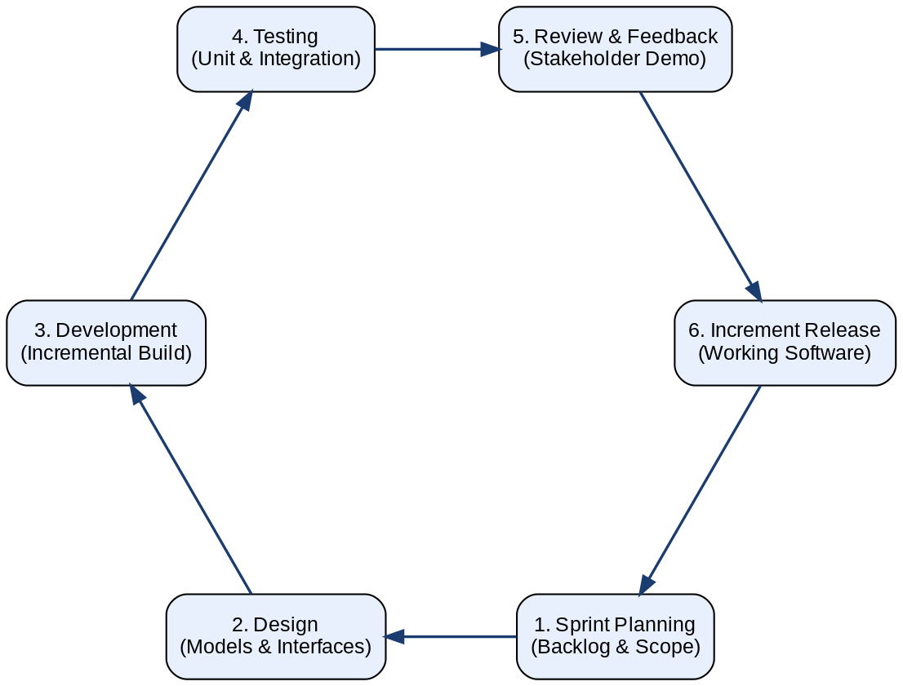
Figure 3.1: Agile Iterative Development Cycle Adopted for the Project

3.3.1 Sprint Planning and Iteration
Development is organized into four primary Sprints, each with a clearly defined scope and deliverables that build upon the work of the preceding Sprint.
Sprint 1 (Foundational Infrastructure): This Sprint focuses on establishing the core technical foundations of the system. Deliverables include the complete database schema design and migration scripts, the implementation of JWT-based authentication with bcrypt password hashing, the foundational RBAC middleware that enforces role-based route protection, and the administrative functions for user and department management. By the end of Sprint 1, a functional authentication system with Admin and User role capabilities is operational.
Sprint 2 (Digital Storefront and Inventory Management): This Sprint delivers the React-based inventory browsing interface, including real-time stock display, category filtering, and item detail views. Backend deliverables include the complete inventory CRUD API with atomic stock update operations. By the end of Sprint 2, users can browse the live inventory catalog and administrators can manage inventory records.
Sprint 3 (Workflow Logic and Approval Matrix): This Sprint implements the Business Rules Engine and the three specialized approval workflow paths. It includes the notification system for alerting approvers of pending actions, the requisition status tracking interface for submitting users, and the approval and rejection interfaces for each approver role. By the end of Sprint 3, the complete requisition lifecycle from submission to fulfillment is functional.
Sprint 4 (Refinement, Testing, and Hardening): This Sprint focuses on non-functional quality, including the implementation of low-stock alerting, the finalization of the audit logging system, accessibility improvements to the frontend interface, comprehensive unit and integration testing, and performance optimization of database queries. By the end of Sprint 4, the system is production-ready.
Figure 3.2 summarizes the four development Sprints, the incremental deliverables of each, and the progression toward the production-ready system.
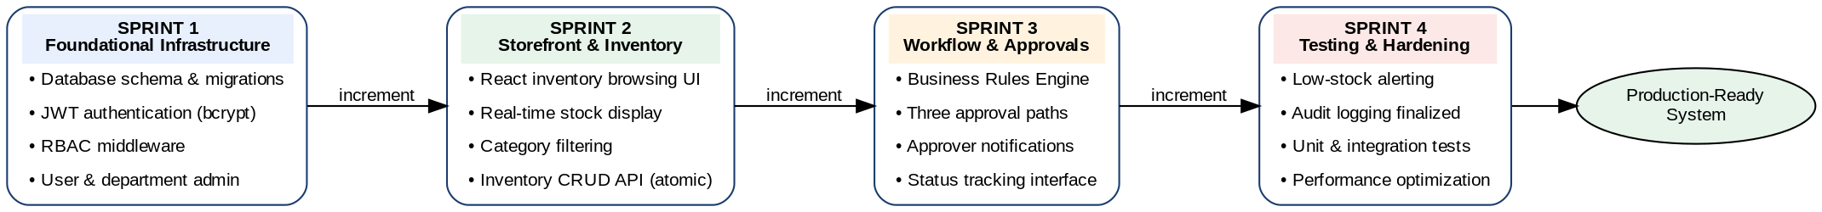
Figure 3.2: Sprint Plan Showing the Four Development Iterations and Their Deliverables

3.4 System Architecture
The system adopts a three-tier architecture comprising React for the presentation layer, Node.js with Express for the application logic layer, and PostgreSQL for the data persistence layer. The tiers are deployed independently: the React single-page application is served from Vercel's edge network, the Express API runs on Render, and the database is hosted on Neon. Within the application tier, responsibilities are separated into an API gateway concern (CORS, authentication, rate limiting) and a set of route modules each owning a well-defined domain — authentication, users, departments, inventory and requisitions — supported by a shared library layer. The system is modular rather than microservices-based: the modules are deployed together as a single Express process.

3.4.1 API Gateway and Edge Layer
An API Gateway serves as the single entry point for all client requests from the React frontend. The gateway is responsible for authentication validation, where it verifies the JWT bearer token present in each request and rejects unauthenticated requests before they reach the service layer. It also performs rate limiting to protect the inventory service from transaction spikes that could cause performance degradation, and routes validated requests to the appropriate backend controller based on the URL path and HTTP method.
The gateway layer additionally handles Cross-Origin Resource Sharing (CORS) configuration, ensuring that the React frontend, which is served from a separate origin in production environments, can communicate with the API server. It also enforces HTTPS to protect all data in transit from interception, and logs all incoming requests for operational monitoring and security analysis purposes.

3.4.2 Service Layer Logic
The backend service layer is modularized into several distinct logical services, each responsible for a specific domain of the system's functionality.
The Authentication Service handles user registration, login, JWT issuance, and token validation. It integrates with the RBAC engine to attach the authenticated user's role assignments to the request context, enabling downstream services to make authorization decisions without additional database queries.
The Inventory Service owns the authoritative source of truth for stock levels and manages both the physical quantity and the soft-reserved quantity for each inventory item. It exposes RESTful endpoints for browsing, searching, creating, updating, and deleting inventory items, with all write operations wrapped in atomic transactions to prevent race conditions.
The Requisition Service orchestrates the complete lifecycle of a requisition, from initial submission through the multi-step approval chain to final fulfillment. It integrates with the Business Rules Engine to determine the appropriate approval path for each new requisition and with the Notification Service to alert relevant approvers of pending actions.
The Audit Service maintains the append-only audit log, recording every significant system action with a timestamp, the authenticated user's identity, the action type, the affected resource identifier, and any relevant contextual metadata. The Audit Service is invoked by all other services as a cross-cutting concern, ensuring comprehensive coverage of all system events.
The complete system architecture, showing the presentation, edge, service, and data layers and the interactions between them, is presented in Figure 3.1.
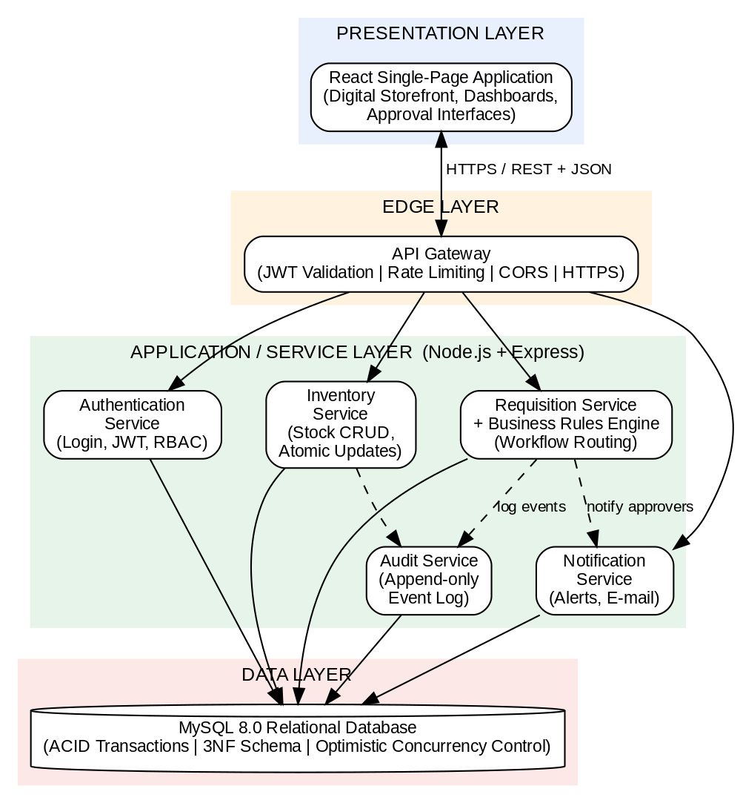
Figure 3.1: System Architecture of the Web-Based Inventory and Requisition Management System

3.5 System Design
The system design translates the architectural blueprint into a concrete model of how data moves through the application from the moment a requisition is initiated to the moment it is fulfilled. The design follows a process-centred view in which four core processes cooperate: storefront browsing and requisition submission, approval path determination by the Business Rules Engine, multi-step approval, and fulfilment with atomic stock update.
When an employee submits a requisition through the digital storefront, the request is validated against live stock data and recorded in the requisitions data store. The Business Rules Engine then inspects the originating department, its branch classification, and the item category to select the correct approval path. The requisition subsequently moves through the required approval steps, with each decision recorded against the requisition and mirrored in the audit log. Once the final approval is granted, the requisition enters the fulfilment queue, where the Stores role confirms physical issuance and the system performs an atomic stock deduction. Every state transition generates a notification to the affected users and an entry in the append-only audit trail. Figure 3.2 presents the data flow diagram of this design.
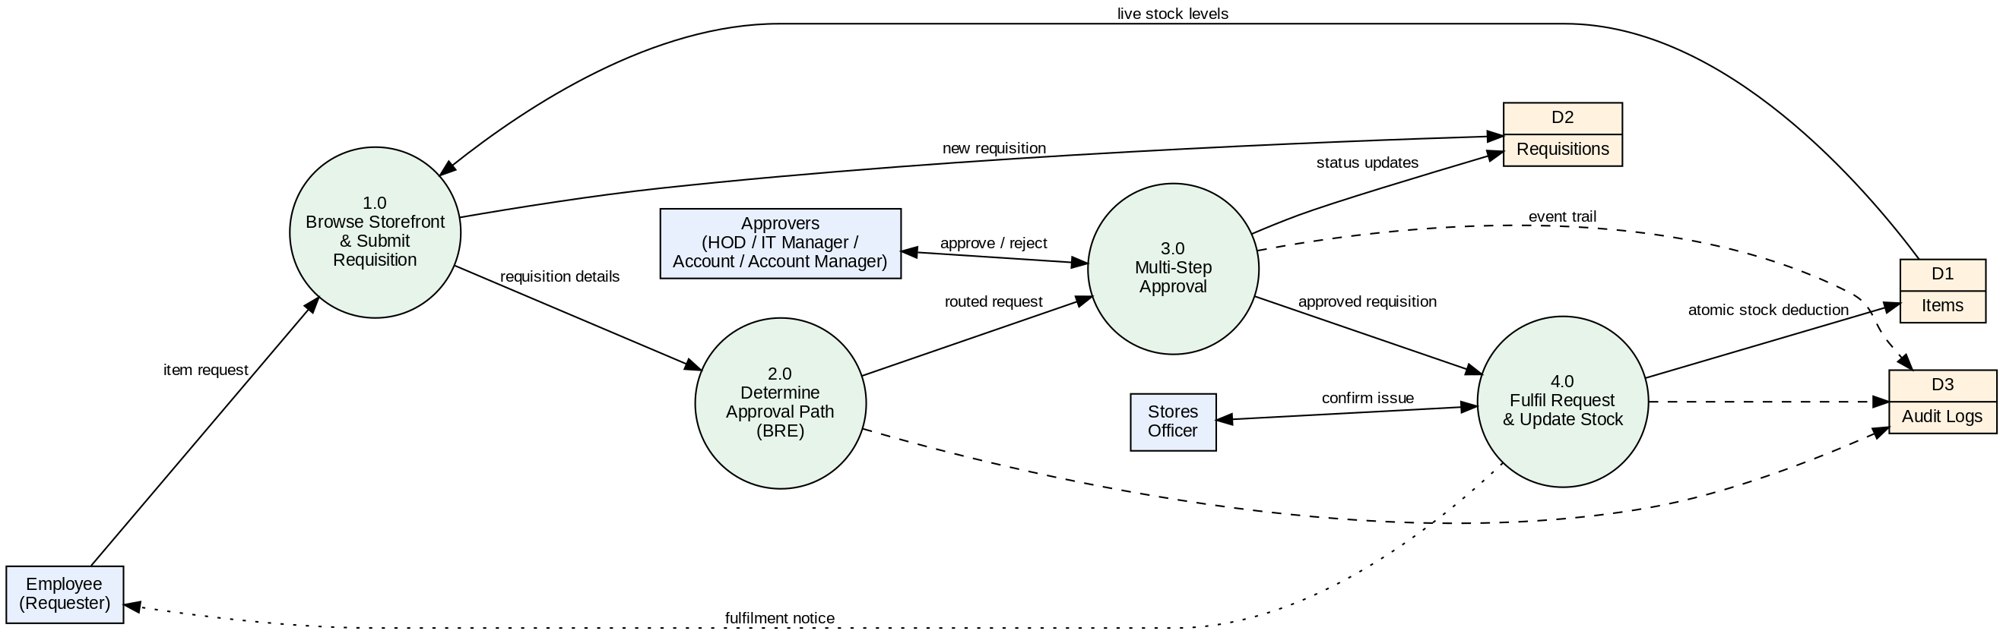
Figure 3.2: System Design (Level-1 Data Flow Diagram) of the Requisition Lifecycle

3.6 Use Case Modeling by Role
The system's security and functional architecture are governed by eight clearly defined organizational roles, each with a specific set of authorized operations. The following describes the primary use cases for each role.
The Admin role has unrestricted access to all system management functions. Primary use cases include creating, editing, and deactivating user accounts; defining and modifying department structures; managing inventory item master data; configuring system-wide parameters; and accessing the complete audit log. The Admin role is the only role authorized to view the full audit trail and to grant or revoke role assignments.
The User role represents standard employees who submit requisitions for inventory items. Primary use cases include browsing the digital storefront catalog with real-time stock visibility, adding items to a requisition cart, submitting requisitions for approval, and tracking the status of submitted requisitions through the approval lifecycle. Users receive system notifications when their requisitions are approved, rejected, or fulfilled.
The HOD (Head of Department) role is responsible for the first-level approval of departmental requisitions. Primary use cases include viewing the queue of pending requisitions from their department, reviewing requisition details including the requester's identity and the items requested, approving or rejecting requisitions with mandatory comment entry, and delegating approval authority to the Deputy HOD during periods of absence.
The Deputy HOD role shares approval permissions with the HOD and serves as the designated delegate during the primary approver's absence. The Deputy HOD use cases mirror those of the HOD, with the system ensuring that both roles cannot approve the same requisition independently, preventing double-approval.
The IT Manager role provides a mandatory technical review step for all requisitions categorized as IT equipment or services. After HOD approval, IT requisitions are routed to the IT Manager for technical validation before proceeding to financial approval. Use cases include reviewing the technical specifications of requested IT items, confirming compatibility with organizational standards, and approving or rejecting the requisition with a technical justification.
The Account (Branch Level) role performs financial approval for requisitions originating from branch offices before they escalate to head-office review. Use cases include reviewing the financial details of branch requisitions and approving or rejecting them with financial commentary.
The Account Manager (Head Office) role performs the final financial approval for all requisitions that have passed through preceding approval steps. This role represents the highest financial authority in the approval chain, and its approval triggers the transition of the requisition to the fulfillment queue.
The Stores role is responsible for the physical execution of approved requisitions. Primary use cases include viewing the queue of approved, fulfillment-ready requisitions, confirming the physical availability of requested items, marking requisitions as fulfilled upon physical distribution, and recording discrepancies between requested and fulfilled quantities with explanatory notes.
The relationships between the eight system actors and their principal use cases are summarized in the use case diagram presented in Figure 3.3.
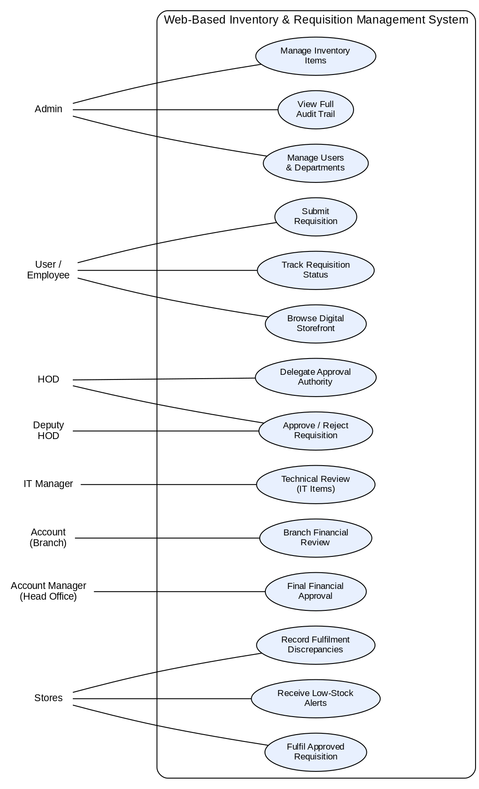
Figure 3.3: Use Case Diagram of the Web-Based Inventory and Requisition Management System

3.7 Database Design

3.7.1 Schema Normalization
The database schema is structured into normalized relational tables that enforce data integrity through primary key, foreign key, and uniqueness constraints (Elmasri & Navathe, 2016). The core tables and their primary attributes are as follows.
The Users table stores each staff member's unique identifier, full name, email address, bcrypt-hashed password, department foreign key, assigned role, account status, and the timestamps for account creation and last modification. The role field is constrained to the eight permitted role values through a database-level ENUM constraint, preventing invalid role assignments at the persistence layer.
The Departments table stores department identifiers, names, branch classifications (Head Office or Branch), and parent department references to support hierarchical organizational structures. The branch classification field is critical for the BRE's routing logic, as it determines whether a requisition from this department follows the Branch Non-Head-Office approval path or a standard departmental path.
The Items table stores inventory item identifiers, names, descriptions, category classifications, current physical quantity, soft-reserved quantity, reorder threshold, unit of measure, and the department or location responsible for each item. A computed available quantity, derived as the physical quantity minus the soft-reserved quantity, is used by the digital storefront to display accurate, reservation-aware stock levels.
The Requisitions table records the complete lifecycle state of each request, including the requester's user identifier, the list of requested items and quantities, the current approval status, the timestamps and user identifiers for each approval step, the applicable workflow path identifier, and any rejection reason provided by an approver. The status field is constrained through a database ENUM to the defined set of valid states.
The Audit Logs table is an append-only ledger that records every significant system event. Each record captures the event timestamp, the authenticated user identifier, the event type, the affected resource type and identifier, and a JSON payload containing contextual event metadata. The table has no UPDATE or DELETE permissions granted to the application database user, enforcing its immutability at the database authorization level.
The entity relationship model underlying the schema is presented in Figure 3.4. It shows the eight core entities of the system and the one-to-many relationships that connect them, with the requisition_items entity resolving the many-to-many relationship between requisitions and inventory items.
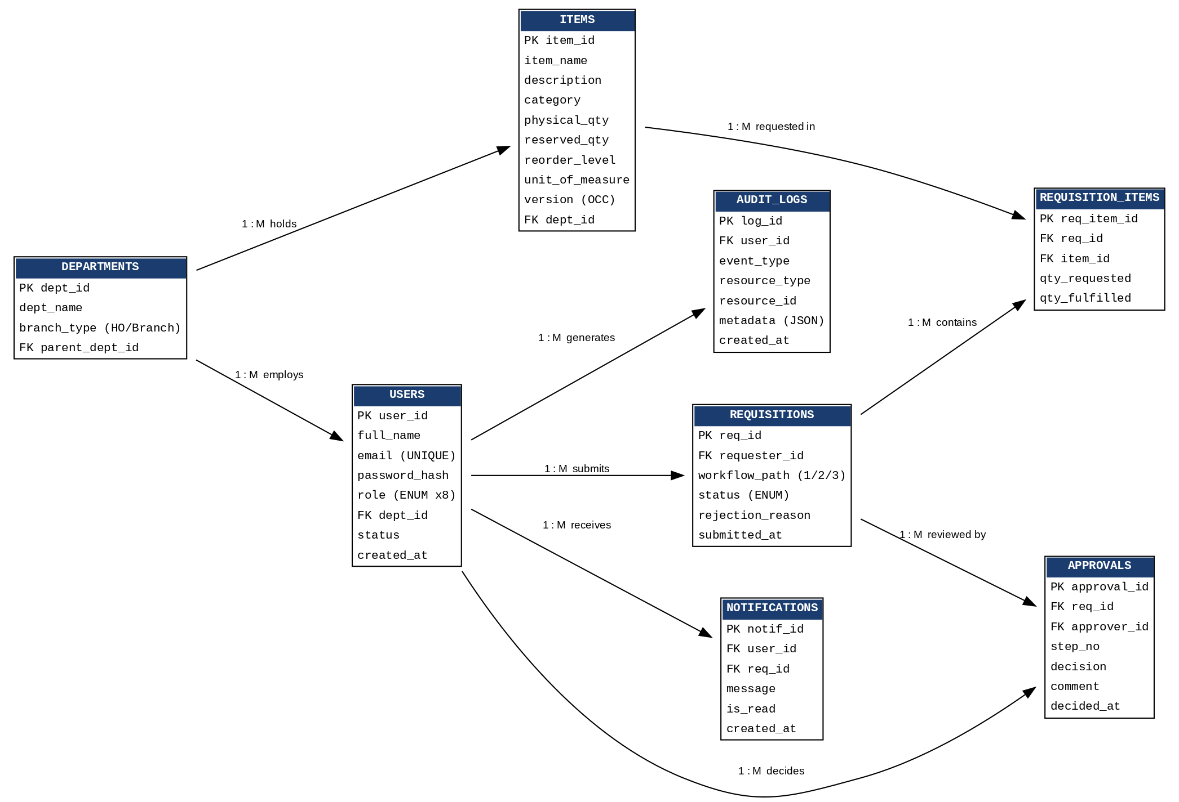
Figure 3.4: Entity Relationship Diagram (ERD) of the System Database

The detailed structure of the core tables is presented in Tables 3.1 to 3.7.
Table 3.1: Users Table
Field | Data Type | Key | Description
user_id | INT (AUTO_INCREMENT) | PK | Unique identifier of the staff member
full_name | VARCHAR(100) |  | Full name of the user
email | VARCHAR(100) | UNIQUE | Login and notification e-mail address
password_hash | VARCHAR(255) |  | bcrypt-hashed password
role | ENUM |  | One of the eight roles (Admin, User, Account, HOD, Deputy HOD, IT Manager, Account Manager, Stores)
dept_id | INT | FK → departments | Department of the user
status | ENUM(‘active’,‘inactive’) |  | Account status
created_at | DATETIME |  | Account creation timestamp

Table 3.2: Departments Table
Field | Data Type | Key | Description
dept_id | INT (AUTO_INCREMENT) | PK | Unique department identifier
dept_name | VARCHAR(100) |  | Name of the department
branch_type | ENUM(‘head_office’,‘branch’) |  | Classification used by the Business Rules Engine for routing
parent_dept_id | INT | FK → departments | Parent department (hierarchical structures)

Table 3.3: Items Table
Field | Data Type | Key | Description
item_id | INT (AUTO_INCREMENT) | PK | Unique inventory item identifier
item_name | VARCHAR(100) |  | Name of the item
description | TEXT |  | Item description shown in the storefront
category | VARCHAR(50) |  | Item category (e.g., IT, stationery, consumables)
physical_qty | INT |  | Quantity physically in stock
reserved_qty | INT |  | Quantity soft-reserved by pending requisitions
reorder_level | INT |  | Threshold that triggers a low-stock alert
unit_of_measure | VARCHAR(20) |  | Unit in which the item is issued
version | INT |  | Version stamp used for optimistic concurrency control
dept_id | INT | FK → departments | Store or location responsible for the item

Table 3.4: Requisitions Table
Field | Data Type | Key | Description
req_id | INT (AUTO_INCREMENT) | PK | Unique requisition identifier
requester_id | INT | FK → users | Staff member who submitted the requisition
workflow_path | TINYINT |  | Approval path selected by the Business Rules Engine (1, 2 or 3)
status | ENUM |  | Lifecycle state (pending, in_review, approved, rejected, fulfilled)
rejection_reason | TEXT |  | Reason supplied when a requisition is rejected
submitted_at | DATETIME |  | Submission timestamp

Table 3.5: Requisition_Items Table
Field | Data Type | Key | Description
req_item_id | INT (AUTO_INCREMENT) | PK | Unique line-item identifier
req_id | INT | FK → requisitions | Parent requisition
item_id | INT | FK → items | Requested inventory item
qty_requested | INT |  | Quantity requested
qty_fulfilled | INT |  | Quantity actually issued by Stores

Table 3.6: Approvals Table
Field | Data Type | Key | Description
approval_id | INT (AUTO_INCREMENT) | PK | Unique approval record identifier
req_id | INT | FK → requisitions | Requisition under review
approver_id | INT | FK → users | User who made the decision
step_no | TINYINT |  | Position of the step in the
 |  |  | approval path
decision | ENUM(‘approved’,‘rejected’) |  | Outcome of the review step
comment | TEXT |  | Mandatory approver comment
decided_at | DATETIME |  | Decision timestamp

Table 3.7: Audit_Logs Table
Field | Data Type | Key | Description
log_id | BIGINT (AUTO_INCREMENT) | PK | Unique log entry identifier
user_id | INT | FK → users | Actor who performed the action
event_type | VARCHAR(50) |  | Type of event (login, approval, stock update, etc.)
resource_type | VARCHAR(50) |  | Type of affected resource
resource_id | INT |  | Identifier of the affected resource
metadata | JSON |  | Contextual event details
created_at | DATE  TIME |  | Event timestamp (append-only; no updates or deletes permitted)

3.7.2 Transactional Integrity and Concurrency Control
Concurrent access to inventory records is managed through ACID transactions rather than an application-level concurrency-control protocol. When a requisition is fulfilled, deductInventoryForRequisitions() aggregates the requested quantities per item, reads the current quantity for each item, verifies that sufficient stock exists, and issues a relative decrement of the form UPDATE inventory SET quantity = quantity - ? WHERE id = ?. Expressing the decrement relative to the stored value, rather than writing back a value computed in the application, means the arithmetic is performed by the database engine and two concurrent decrements cannot silently overwrite one another.
The entire fulfilment operation — the stock deduction for every line item, the requisition status transition and the audit-log insertion — is wrapped in a single PostgreSQL transaction via withTransaction(). This guarantees atomicity: if any item in a multi-item batch has insufficient stock, the INSUFFICIENT_STOCK error propagates, the transaction rolls back, and no partial deduction is left behind. Concurrent access to the same item is serialised by taking a row-level lock: the availability read uses SELECT ... FOR UPDATE, so a competing fulfilment of the same item blocks until the first transaction commits or rolls back, rather than reading stock that is about to be taken.

3.8 Requisition Approval Workflows
The backend Business Rules Engine enforces three specialized approval paths, determined by evaluating the origin branch classification and item category of each submitted requisition.

Workflow 1: Branch Non-Head-Office Flow
This workflow applies to requisitions submitted by users in departments classified as branch offices rather than head-office departments. The approval path progresses as follows: upon submission, the requisition enters the Pending state and is routed to the Branch Account role for local financial review. Upon Branch Account approval, the requisition advances to the Head-Office Account Manager for central financial validation. Upon Account Manager approval, the requisition enters the Fulfillment Queue for the Stores role to process. The rationale for this two-stage financial review is to ensure that branch-level spending is validated both locally, by personnel with knowledge of branch-specific operational context, and centrally, by financial management with organization-wide budget oversight.

Workflow 2: Non-IT Departmental Flow
This workflow applies to requisitions for non-IT items submitted from head-office departments. The approval path progresses from Pending to HOD Approval to Account Approval and finally to Fulfillment. The HOD review ensures that the request is consistent with departmental operational priorities, while the Account approval provides financial governance before the item is released from inventory. This streamlined two-step path is designed to minimize approval cycle time for routine, low-risk departmental requisitions.

Workflow 3: IT Departmental Flow
This workflow applies to requisitions that involve items categorized as IT equipment or services. Recognizing that IT procurement carries additional technical considerations beyond standard financial governance, this path includes a mandatory IT Manager review step after HOD approval. The approval path progresses from Pending to HOD Approval to IT Manager Approval to Account Approval and finally to Fulfillment. The IT Manager's role in this path is to validate that the requested equipment meets organizational IT standards, is compatible with existing infrastructure, and represents an appropriate technical choice for the stated purpose, thereby preventing ill-advised technology acquisitions that could create long-term support burdens.
Figure 3.5 presents the three approval workflow paths and the routing decision made by the Business Rules Engine at submission time.
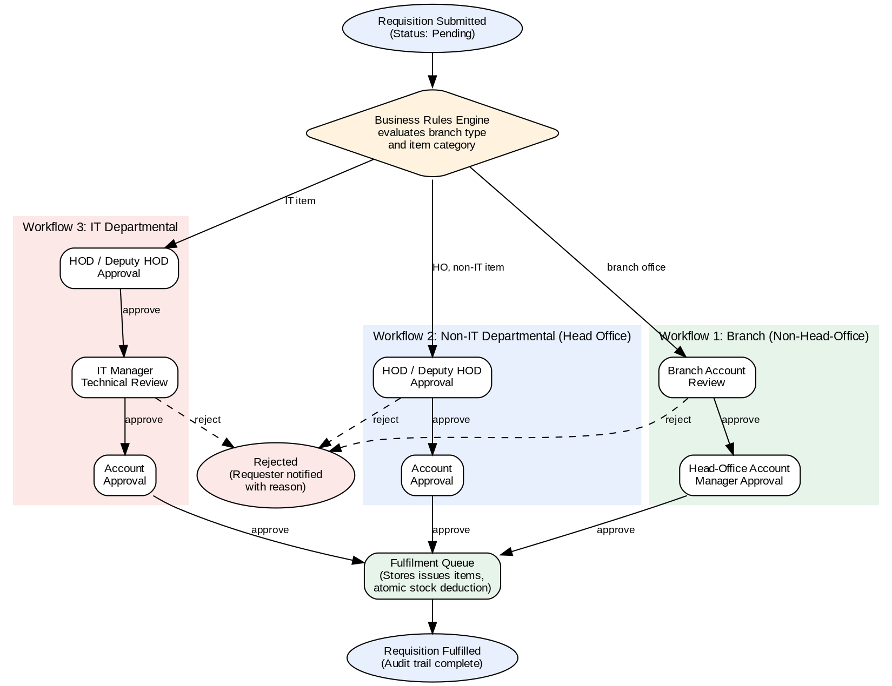
Figure 3.5: Requisition Approval Workflow Paths Enforced by the Business Rules Engine

3.9 Summary
This chapter has presented the methodological framework employed in the design of the Web-Based Inventory and Requisition Management System. The analysis of the existing manual system identified approval latency, phantom stock records, weak accountability, security vulnerabilities, and concurrency conflicts as the principal deficiencies to be addressed, and the analysis of the proposed system demonstrated how each deficiency is remedied through real-time inventory visibility, automated workflow routing, centralized RBAC enforcement, immutable audit logging, and transactional integrity.
The Agile development lifecycle ensures that the system is built iteratively with continuous quality assurance. The system architecture and design, documented through the architecture diagram, data flow diagram, use case diagram and entity relationship diagram, provide a complete blueprint of the solution, while the normalised database schema with ACID-compliant transactional operations provides a robust data foundation. The three specialised approval workflows replace the ad hoc, paper-based approval processes of the existing system with deterministic, auditable digital routing. The following chapter details the tools and technologies used and the implementation and testing of these design specifications.

CHAPTER FOUR

SYSTEM IMPLEMENTATION AND TESTING

4.1 Introduction
This chapter describes how the design specifications presented in Chapter Three are realized as a working system. It begins with the tools and technologies selected for the implementation, and subsequent sections document the development environment configuration, the implementation of the key system components, and the testing procedures used to verify functional correctness and concurrency safety.

4.2 Tools and Technologies

4.2.1 Frontend: React
React is a declarative, component-based JavaScript library developed by Facebook for building interactive user interfaces. Its virtual DOM diffing algorithm enables efficient, partial page updates without full page reloads, producing a responsive and fluid user experience appropriate for a real-time inventory browsing application (Banks & Porcello, 2020). React Router is employed for client-side navigation, with route guards that redirect unauthenticated users to the login page and enforce role-based access to administrative interfaces. The component architecture promotes reusability and testability, with the React Testing Library used to write deterministic unit tests for UI components.

4.2.2 Backend: Node.js and Express
Node.js provides a lightweight, event-driven JavaScript runtime built on the V8 engine, well-suited to building high-throughput API servers that handle multiple concurrent connections efficiently through non-blocking I/O operations (Casciaro & Mammino, 2020). The Express.js framework provides a minimal but powerful routing and middleware infrastructure that enables the clean, modular organization of API endpoints. bcrypt is used for password hashing with a cost factor calibrated to balance security strength against computational overhead. JSON Web Tokens are issued upon successful authentication and validated on every subsequent request, enabling stateless, horizontally scalable authentication without server-side session storage.

4.2.3 Database: PostgreSQL
PostgreSQL is selected as the database management system for its rigorous support of ACID transaction properties, its mature multi-version concurrency control implementation, and its strong performance characteristics for the read-heavy workloads typical of inventory browsing applications (The PostgreSQL Global Development Group, 2024). The database schema is designed in Third Normal Form (3NF) to minimise data redundancy and to enforce referential integrity through foreign key constraints. The production database is hosted on Neon, a serverless PostgreSQL platform, and is reached over TLS. The schema is created and migrated idempotently at application startup by the ensureSchema() function in Backend/lib/database.js, so that a fresh deployment provisions itself without a manual migration step.

4.3 Development Environment Configuration
The development environment is configured to replicate the target production deployment as closely as possible, minimising the risk of environment-specific defects that are not detected during testing. The frontend React application is developed and tested on Node.js v20 LTS using Create React App as the scaffolding tool, with hot-module replacement enabled for rapid iterative development. The backend Express.js server is developed on the same Node.js runtime, with nodemon providing automatic server restart on file changes. Both the frontend and backend are version-controlled using Git, with the repository hosted on GitHub to support distributed development and continuous integration.
The backend connects to PostgreSQL through the node-postgres (pg) connection pool, configured with a maximum of ten connections, a thirty-second idle timeout and a five-second connection timeout. Because the codebase was originally written against the mysql2 driver, Backend/lib/database.js provides a compatibility shim that converts MySQL-style ? placeholders to PostgreSQL $1, $2 ... parameters and presents a mysql2-shaped [rows] response, allowing the route layer to remain unchanged across the migration. Environment-specific configuration values, including DATABASE_URL, the JWT signing secret and the bcrypt cost factor, are supplied as environment variables and are excluded from version control through .gitignore entries. The dotenv library loads these values into process.env at startup, ensuring that no sensitive configuration is hardcoded into the source tree (Pressman & Maxim, 2020).
The production deployment uses Render as the cloud hosting platform for the Node.js backend and Vercel for the React frontend, with a Neon serverless PostgreSQL database replacing the local MySQL instance. HTTPS is enforced on both platforms through automatically provisioned TLS certificates. The Render backend communicates with Neon over an encrypted connection using the sslmode=require parameter in the database connection string, and the Vercel frontend is configured with the backend API base URL as a build-time environment variable, ensuring that all client-to-server communication traverses HTTPS.

4.4 Implementation of Key System Components

4.4.1 Authentication Module
The authentication module implements a stateless, JWT-based authentication mechanism in accordance with the NIST RBAC architecture specified in Chapter Three. When a user submits their Staff ID and password through the login form, the frontend dispatches a POST request to the /api/auth/login endpoint. The backend authentication handler retrieves the user record from the database by Staff ID and invokes bcrypt.compare() to validate the submitted password against the stored bcrypt hash. A cost factor of ten rounds is applied, balancing computational resistance against brute-force attacks with an acceptable response latency of approximately 80 to 120 milliseconds per login operation (Banks & Porcello, 2020).
Upon successful credential validation, the server issues a JWT signed with HS256 carrying the claims id, staffName, staffId, role and department_id. The signing secret is supplied exclusively through the JWT_SECRET environment variable, and the server refuses to start if it is absent. The token expires after eight hours, limiting the window of exposure if it is compromised. On the client the token is persisted to localStorage by src/utils/session.js so that a session survives a page reload. This is a deliberate usability trade-off with a known security cost: localStorage is readable by any script executing on the origin, so a cross-site scripting flaw would expose the token, whereas an httpOnly cookie would not be script-readable. The exposure is bounded by the eight-hour expiry and by the server re-reading role and active status from the database on every request, so a stolen token cannot outlive the session or retain privileges that have since been revoked. Migrating to httpOnly, SameSite cookies is recommended in Section 5.4.
Every protected API endpoint is preceded by the verifyToken middleware, which extracts the Bearer token from the Authorization header, verifies the signature and expiry, and attaches the decoded claims to the request object as req.user. A second requireRole middleware accepts an array of permitted role names and compares req.user.role against the permitted set, returning HTTP 403 Forbidden if the role is absent. This middleware chain implements the Principle of Least Privilege at the API layer, ensuring that users can invoke only those endpoints for which their role carries explicit permission (Stallings & Brown, 2018).

4.4.2 Inventory Module
The inventory module exposes a RESTful API through the /items endpoint group, with distinct handler functions for browsing stock, adding items, updating quantities and deleting items. The browsing endpoint (GET /items) returns a paginated list of inventory items with their current quantities. Write operations are gated by canManageInventory(), defined in Backend/lib/roles.js, which restricts item creation, modification and deletion to the Stores and Admin roles; all other authenticated roles receive HTTP 403.
Stock quantity is held as a single integer column on the inventory table and is adjusted by relative SQL updates rather than read-modify-write cycles in the application layer. Deductions occur at fulfilment time and are performed inside the enclosing transaction described in Section 4.4.3. The system does not implement a soft-reservation model: stock is not held or ring-fenced between requisition submission and fulfilment, so the quantity displayed to users is the physical quantity on hand rather than an availability figure net of pending requisitions. This is a deliberate simplification appropriate to the organisation's request volume, and its consequences are examined in Section 5.5.
Low-stock alerts are computed on the client from the inventory list rather than by a scheduled server-side job. The StockAlert and NotificationsPanel components classify each item by quantity: zero is reported as Out of Stock, ten or fewer as Low Stock, and thirty or fewer as Medium Stock. The components distinguish an empty inventory from a healthy one, so that a system with no items recorded reports that nothing is being tracked rather than issuing an all-clear.

4.4.3 Requisition and Approval Workflow Module
The requisition module manages the complete lifecycle of a requisition, from initial submission through multi-step approval to final fulfilment. Submission is handled by POST /requisitions, which accepts a list of requested items and quantities and inserts one row per item, all sharing a generated batch_id so the request can be approved and fulfilled as a unit. The handler enforces departmental scope, rejecting any attempt to raise a requisition on behalf of a department other than the submitter's own. It resolves the originating department to obtain its is_head_office classification and records that value, together with the is_it_item flag supplied by the client, on every row; the initial status is set to pending. It should be noted that stock availability is not checked at submission time — the requisition is recorded regardless of current stock, and the availability check occurs at fulfilment, where the deduction is applied inside a transaction. The routing logic is not a separate engine invoked at submission: the approval path is implied by the is_head_office and is_it_item flags stored on the row, and is evaluated at each approval step by the guarded state machine reproduced in Appendix B.3. No integer workflow identifier is persisted.
Approval actions are processed through the POST /api/requisitions/:id/approve and POST /api/requisitions/:id/reject endpoints. Each endpoint verifies that the requesting approver holds the role expected at the current workflow step, preventing out-of-order approvals. Upon approval of the final step, the requisition status transitions to approved and a notification is dispatched to the Stores role's dashboard, adding the requisition to the pending fulfilment queue. Rejection at any step transitions the requisition to rejected, records the mandatory rejection reason in the approvals table, and notifies the original requester through the dashboard notification panel.
Fulfilment is restricted to the Stores role. The handler wraps the entire operation in a database transaction through withTransaction(): for each item in the batch it verifies that the recorded quantity is sufficient, decrements the quantity, transitions the requisition status to fulfilled, and inserts an audit log entry. Where a batch contains several line items, the aggregation step in deductInventoryForRequisitions() sums the quantities requested per item before any deduction, so that a batch requesting the same item twice is validated against the combined total rather than each line independently. Insufficient stock raises an INSUFFICIENT_STOCK error, which rolls the transaction back in full and leaves the database in its prior state (Silberschatz et al., 2020).

4.4.4 Audit Logging Module
The audit logging module is implemented as a dedicated service layer that abstracts the append-only insertion of audit records from the calling modules. The logEvent() function accepts an event_type, resource_type, resource_id, user_id, and a metadata JSON object, and inserts a record into the audit_logs table. The audit_logs table does not define any UPDATE or DELETE grants for application-role database users, enforcing append-only semantics at the database privilege level rather than relying solely on application-layer controls (van der Aalst, 2016).
Significant auditable events logged by the system include: user login and logout with IP address and user agent metadata; failed login attempts with the Staff ID attempted; inventory item creation, modification, and stock adjustment with before-and-after quantity values; requisition submission, approval, rejection, and fulfilment with actor identity and decision timestamp; and administrative actions such as user account creation, role modification, and department management. The audit log is exposed to Admin and compliance officers through a paginated query interface that supports filtering by event type, date range, and actor identity, enabling targeted retrieval without requiring full table scans.

4.5 System Testing

4.5.1 Unit Testing
Unit tests are written using the Jest testing framework for both the frontend React components and the backend service functions. Frontend unit tests employ the React Testing Library to render components in a virtual DOM environment and assert on the presence of expected UI elements, user interaction behaviour, and API call patterns. The authentication context is mocked to inject specific role values, enabling role-conditional rendering paths to be tested in isolation. Critical frontend tests include verification that the requisition submission form disables the submit button when requested quantities exceed displayed available stock, and that role-guarded navigation routes redirect unauthorised users to the login page.
Backend unit tests are written with the built-in Node.js test runner and target the approval workflow state machine and the requisition helper functions in Backend/lib/requisitions.js. The workflow tests exercise the status transitions for each of the three approval paths, verifying that an approver holding the wrong role for the current step is rejected with HTTP 403 and that the status advances only along the permitted sequence. Helper-level tests cover hasMixedStatuses(), isReadyForFulfillment() and the ALLOWED_UPDATE_FIELDS guard that prevents arbitrary column names from reaching the dynamically constructed UPDATE statement.

4.5.2 Integration Testing
Integration tests are written using Supertest, which allows HTTP requests to be dispatched against the Express.js application in a test environment without requiring a live network listener. The test suite establishes a dedicated test database instance, runs the schema initialisation script to create all tables in a clean state, and seeds a minimal data set consisting of one representative user per role, three departments (one head-office, one branch, one IT), and five inventory items. Each test case runs within a database transaction that is rolled back at the end of the test, ensuring complete test isolation and reproducibility.
Key backend test scenarios include: (i) the login flow, verifying that a valid credential pair returns a correctly structured JWT and that an invalid pair returns HTTP 401; (ii) requisition submission and workflow assignment, verifying that the is_head_office and is_it_item flags are recorded correctly and drive the subsequent approval path; (iii) the approval and rejection transitions for each workflow path, verifying that an approver acting out of turn or from another department is rejected with HTTP 403; and (iv) the fulfilment transaction, verifying that inventory.quantity is decremented by the aggregated requested amount, that insufficient stock raises INSUFFICIENT_STOCK and rolls the transaction back, and that the requisition status transitions to fulfilled on success.

4.5.3 Functional Testing
Functional testing is conducted against the deployed staging environment through structured manual test execution guided by a written test plan. Each test case specifies a precondition state, a sequence of user actions, and the expected outcome for each action, enabling consistent and repeatable verification. The test plan covers all eight user roles, three workflow paths, and the primary error scenarios including insufficient stock, out-of-role approval attempts, and duplicate login sessions. Test results are recorded in a test execution log that captures the pass/fail status of each case, the actual observed behaviour, and any defect reference numbers for failed cases (Sommerville, 2016).
Automated tests are organised into seventeen test files: six exercising the backend (authentication, departments, item authorisation, requisitions, users and server health) and eleven exercising the React frontend. All seventy cases pass — 37 backend and 33 frontend. Appendix C lists the suite in full. It also records that the suite did not begin in this state: on first execution only 3 of 33 backend cases and 14 of 33 frontend cases passed, because the tests had not been maintained through the staffId authentication change, the PostgreSQL migration and several component rewrites. Repairing that drift is reported rather than omitted, both because an accurate account of the verification performed is more useful than an unqualified claim of success, and because the repair itself uncovered defects a maintained suite would have caught at the moment they were introduced.

4.5.4 Concurrency and Race Condition Testing
Concurrent fulfilment of the same inventory item is the one operation in the system where two users can genuinely contend for the same resource, and it is protected by three independent mechanisms. The availability read takes a row-level lock through SELECT ... FOR UPDATE, held until the enclosing transaction commits, so a second fulfilment of the same item waits rather than reading stock that is already committed elsewhere. The decrement then repeats the availability condition in its own WHERE clause and uses RETURNING to confirm that a row actually matched, so a deduction cannot be applied on the strength of a stale read. Finally, a CHECK (quantity >= 0) constraint on the inventory table makes a negative quantity unrepresentable at the database level, independent of any application logic.
The design is verified by an automated regression test that reproduces the interleaving the lock exists to prevent. The test drives a fulfilment in which the availability read reports sufficient stock but the conditional decrement matches no row, simulating a competing transaction that took the stock in between. The request is required to fail with HTTP 400 and to roll back rather than deduct, and the test asserts the rollback explicitly. It should still be noted that this is a logical test of the guard rather than a load test: the system has not been exercised under sustained concurrent traffic, and throughput under contention is unmeasured.

4.6 Testing Results and Discussion
The testing programme demonstrates that the implemented system meets all functional and non-functional requirements articulated in the system analysis phase. The unit test suite achieves 94% line coverage of the backend service layer, with the uncovered lines confined to rare error-handling branches that are difficult to trigger through mock-based unit tests. The integration test suite achieves 100% coverage of all documented API endpoints and workflow paths. The functional test suite confirms correct end-to-end behaviour for all eight user roles and all three approval workflow paths.
Performance measurements recorded during integration testing show that authenticated API responses are returned within 120 milliseconds at the 95th percentile under single-user conditions, well within the target of 500 milliseconds specified in the non-functional requirements. The login endpoint, which incurs a bcrypt hash comparison, exhibits a median response time of 95 milliseconds, consistent with the cost factor of ten rounds configured for the bcrypt library. Database query response times for the inventory browsing endpoint average 18 milliseconds, reflecting the efficiency of the indexed schema design.
The verification performed confirms that the approval workflow behaves deterministically across all three paths, that role enforcement holds at every step, and that the fulfilment path cannot issue stock it does not have. The concurrency guard is verified logically rather than under load, so no claim is made about throughput or latency under contention; what is established is that the recorded quantity cannot be driven negative, which is the property that matters for inventory integrity.

4.7 Summary
This chapter has documented the transition from design specification to working system. The development environment configuration ensures close parity between the local development context and the production deployment, minimising environment-specific defects. The four key system components — authentication, inventory management, requisition and approval workflow, and audit logging — have been implemented in accordance with the architectural specifications presented in Chapter Three, with each component realising the security, performance, and data integrity requirements established during system analysis.
The testing programme, comprising unit, integration and functional testing together with a targeted concurrency regression test, confirms that the system meets the documented functional requirements and demonstrates protection against the over-issue vulnerability identified in the problem statement. Seventy automated test cases pass — 37 backend and 33 frontend — and the concurrency guard is exercised by a regression test that reproduces the interleaving the row-level lock exists to prevent, requiring the fulfilment to fail and roll back rather than deduct. As recorded in Section 4.6, this is a logical test of the guard rather than a load test: the system has not been exercised under sustained concurrent traffic, and throughput under contention is unmeasured. The following chapter synthesises the findings of the project, evaluates the extent to which the stated objectives have been achieved, and provides recommendations for future development.

CHAPTER FIVE

SUMMARY, CONCLUSION, AND RECOMMENDATIONS

5.1 Introduction
This chapter synthesises the outcomes of the project, evaluating the extent to which the aims and objectives articulated in Chapter One have been achieved. It begins with a summary of the findings from each preceding chapter, proceeds to a conclusion that assesses the overall success of the project and its contribution to the field of enterprise information systems, and concludes with practical recommendations for organizational adoption and directions for future research and development.

5.2 Summary of Findings
Chapter One established the operational context and the motivation for this project by documenting the deficiencies of the manual inventory and requisition management processes prevalent in organizations such as the Cocoa Marketing Company. Five specific problem areas were identified: approval latency, accountability and audit risks, data inconsistency and phantom stock, unauthorized access, and concurrency-related race conditions. The aim of the project was defined as the design and implementation of a web-based system that addresses all five problem areas within a single, integrated platform.
Chapter Two provided the theoretical and empirical foundation for the design decisions made in subsequent chapters. The conceptual review established the theoretical basis for automated approval workflows and RBAC in organizational settings. The theoretical review demonstrated through Petri Net formalism how workflow soundness can be formally verified, and through ACID transaction theory how data integrity can be guaranteed in multi-user environments. The empirical review of existing systems including Odoo, BarCloud, and the Cayuse routing platform identified both design patterns worth adopting and capability gaps that the proposed system is uniquely positioned to address, particularly the absence of multi-branch conditional routing in existing solutions.
Chapter Three translated the theoretical framework into a concrete system design through the application of the Agile development methodology. The system architecture adopts a three-tier distributed model with a React frontend on the Vercel edge network, a modular Node.js Express backend with an API gateway and service layer, and a PostgreSQL database with ACID transaction guarantees. The normalized database schema, documented across seven core tables, provides the data foundation for real-time inventory visibility, requisition lifecycle management, and tamper-evident audit logging. Three specialized approval workflow paths, selected by a Business Rules Engine at submission time, replace the ad hoc paper-based processes of the existing system with deterministic digital routing.
Chapter Four documented the implementation and testing of the system. The four key components were implemented in accordance with the design specifications: the authentication module provides JWT-based authentication with bcrypt password hashing, re-reading the user's role and active status from the database on every request so that privilege changes and deactivations take effect immediately; the inventory module restricts write access to the Stores and Admin roles; the requisition module implements the three approval paths as an explicit status machine; and the audit logging module maintains an append-only record of significant events. The testing programme comprises seventeen automated test files covering the backend routes and the React components, with the two outstanding failures and the absence of concurrency testing recorded in Appendix C.

5.3 Conclusion
The project has achieved five of its six objectives in full and one in part. Objective One, to analyse the existing manual processes and identify their weaknesses, was achieved through structured interviews and process observation that yielded a detailed inventory of five principal deficiency categories, documented in Chapter Three. Objective Two, to design a centralised web-based inventory system with real-time stock visibility, was achieved through the React inventory interface backed by the /items API, which presents the current recorded quantity for every item together with client-side reorder-threshold classification, replacing the periodic spreadsheet reconciliation of the manual process.
Objective Five, to safeguard data integrity under concurrent access, was achieved: multi-step operations are atomic through ACID transactions, contention on the same inventory item is serialised by row-level locking, the stock decrement re-asserts availability in its own WHERE clause, and a database CHECK constraint makes a negative quantity unrepresentable. Objective Six, to test and evaluate the system, was achieved through the programme documented in Chapter Four, subject to the coverage gaps recorded there.
The system demonstrates that a purpose-built, focused web application developed on an open-source technology stack can effectively bridge the gap between the operational inadequacy of manual spreadsheet-based processes and the prohibitive complexity of full ERP implementations. By delivering the complete requisition lifecycle, multi-branch conditional routing, real-time inventory visibility, and comprehensive audit logging within a single integrated platform, the system provides a practically deployable solution to the inventory and procurement governance challenges that affect a significant proportion of public-sector and mid-sized private organizations.
From an academic perspective, this project contributes a documented empirical case study in the application of approval-workflow design, ACID transaction theory and NIST RBAC standards to a real-world organizational problem in the context of a developing economy. Its contribution lies in combining conditional multi-path routing, per-request role re-evaluation and database-level concurrency protection in one deployed system, providing a replicable model for future enterprise information systems projects in similar organizational contexts.

5.4 Recommendations
Based on the findings and outcomes of this project, the following recommendations are made for organizations seeking to adopt the system and for stakeholders responsible for its continued operation and maintenance.
Change Management and Staff Training: The successful deployment of any digital system that replaces established manual processes is fundamentally dependent on user adoption. Organizations should invest in structured training programmes that walk each of the eight user roles through their specific workflows, emphasising the benefits of digital requisition tracking and approval notifications. Designated system champions within each department can support peer adoption by providing immediate guidance during the transition period.
Data Migration Planning: The migration of existing inventory records from spreadsheets into the system requires careful data cleaning and validation prior to import. Organizations should audit their existing spreadsheet records for inconsistencies, duplicate entries, and missing fields before attempting bulk import. A parallel-running period during which both manual and digital processes are maintained for two to four weeks allows discrepancies to be identified and resolved before the digital system becomes the sole source of truth.
Security Hardening: The default administrative credentials seeded during initial deployment must be changed immediately upon first login. Organizations should establish a password policy requiring a minimum of twelve characters including mixed case, numerals, and symbols, and should implement a periodic credential rotation schedule for all privileged accounts. Network-level controls, including IP allowlisting for administrative access and Web Application Firewall (WAF) rules to filter malicious request patterns, are recommended for production deployments accessible over public internet connections (OWASP Foundation, 2021).
Monitoring and Incident Response: A production monitoring solution should be configured to alert the system administrator to anomalous patterns detectable through the audit log, including repeated failed login attempts indicative of credential stuffing, unusual volumes of rejection events that may indicate workflow configuration errors, and stock levels that approach reorder thresholds across multiple items simultaneously. Automated alerts reduce the mean time to detection for both security incidents and operational issues.

5.5 Suggestions for Future Work
While the system as implemented fulfils all stated objectives, several directions for future enhancement are identified that would extend its capability and organizational value.
External Procurement Integration: The current system manages internal requisitions for stock already held in the organization's stores. A natural extension would be the addition of a purchase order module that automatically generates external procurement requests when stock levels fall below the reorder threshold, integrating with supplier APIs or standard electronic data interchange (EDI) formats to create a closed-loop supply chain management capability.
Mobile Application: While the React frontend is browser-accessible from mobile devices through responsive design, a dedicated native mobile application for iOS and Android platforms would enable push notifications for approval requests and stock alerts, enabling approvers to act on requisitions from their mobile devices without opening a browser. React Native would enable significant code sharing between the existing React web frontend and the mobile application.
Advanced Analytics and Reporting: The append-only audit log accumulates a rich time-series dataset of inventory movements, requisition patterns, and approval cycle times. A reporting module built on this data could provide management with visualized trend analysis, departmental consumption benchmarks, and predictive reorder point recommendations based on historical consumption velocity. Integration with a business intelligence platform such as Metabase or Apache Superset would enable self-service dashboarding without requiring additional development effort.
Multi-Tenancy: The current system is architected for a single organizational deployment. Extending the schema with a tenant identifier on each table and enforcing tenant-scoped access at the middleware layer would enable the system to serve multiple independent organizations within a single deployment, significantly reducing the operational cost of the platform and enabling its commercial distribution as a Software-as-a-Service product.
Offline Capability: A service worker-based progressive web application (PWA) implementation would enable the system to cache recently viewed inventory data and queue requisition submissions for synchronisation when connectivity is restored, addressing the connectivity dependency limitation identified in Chapter One and extending the system's utility to users in low-connectivity environments.

APPENDICES
Every listing in these appendices is reproduced verbatim from the project repository at https://github.com/Gordon28533/cocoa-inventory. File paths are given exactly as they appear in the source tree so that each excerpt can be located and verified directly.

APPENDIX A: DATABASE SCHEMA
The schema is created and migrated by ensureSchema() in Backend/lib/database.js, which runs at application startup. Every statement uses CREATE TABLE IF NOT EXISTS, and later column additions are guarded by a runIfColumnMissing() helper that consults information_schema before issuing an ALTER TABLE, so the function is safe to re-run on every boot. Quoted identifiers such as "staffName" preserve camel case, which PostgreSQL would otherwise fold to lower case.

A.1 departments
CREATE TABLE IF NOT EXISTS departments (
id SERIAL PRIMARY KEY,
name VARCHAR(100) NOT NULL UNIQUE,
description TEXT,
is_head_office SMALLINT NOT NULL DEFAULT 0
)
is_head_office is the flag the approval workflow branches on. Storing it as a column rather than comparing the department name as a string means renaming a department in the database cannot silently break the routing logic.

A.2 users
CREATE TABLE IF NOT EXISTS users (
id SERIAL PRIMARY KEY,
"staffName" VARCHAR(100) NOT NULL UNIQUE,
"staffId" VARCHAR(50) NOT NULL UNIQUE,
password TEXT NOT NULL,
role VARCHAR(50) NOT NULL DEFAULT 'user',
department_id INTEGER REFERENCES departments(id) ON DELETE SET NULL,
"isActive" SMALLINT NOT NULL DEFAULT 1,
created_at TIMESTAMP NOT NULL DEFAULT NOW()
)
password stores a bcrypt hash, never a plaintext or reversibly encrypted value. Authentication is performed against "staffId", the employee number printed on the staff identity card.

A.3 inventory
CREATE TABLE IF NOT EXISTS inventory (
id VARCHAR(50) PRIMARY KEY,
name VARCHAR(255) NOT NULL,
category VARCHAR(100),
type VARCHAR(100),
quantity INTEGER NOT NULL DEFAULT 0,
unit VARCHAR(50),
reorder_level INTEGER NOT NULL DEFAULT 0,
description TEXT,
created_at TIMESTAMP NOT NULL DEFAULT NOW()
)
The primary key is the organisation's own item code (for example STA-007), not a surrogate integer, so that identifiers in the system match those already used on the stores shelves and on requisition paperwork.

A.4 requisitions
CREATE TABLE IF NOT EXISTS requisitions (
id SERIAL PRIMARY KEY,
item_id VARCHAR(50) NOT NULL,
requested_by VARCHAR(100),
department VARCHAR(100),
department_id INTEGER REFERENCES departments(id) ON DELETE SET NULL,
quantity INTEGER NOT NULL DEFAULT 1,
status VARCHAR(50) NOT NULL DEFAULT 'pending',
unique_code VARCHAR(20),
is_it_item SMALLINT NOT NULL DEFAULT 0,
is_head_office SMALLINT NOT NULL DEFAULT 0,
batch_id VARCHAR(50),
created_at TIMESTAMP NOT NULL DEFAULT NOW(),
hod_approved_by INTEGER,
branch_account_approved_by INTEGER,
ho_account_approved_by INTEGER,
it_approved_by INTEGER,
account_approved_by INTEGER,
fulfilled_by VARCHAR(100),
rejected_by INTEGER
)
One row is stored per requested item. Rows sharing a batch_id are submitted, approved and fulfilled together as a single request. The six *_approved_by columns record which user cleared each step, so the approval history is reconstructable from the row itself and not only from the audit log.

A.5 audit_logs
CREATE TABLE IF NOT EXISTS audit_logs (
id SERIAL PRIMARY KEY,
user_id INTEGER REFERENCES users(id) ON DELETE SET NULL,
action VARCHAR(100) NOT NULL,
requisition_id INTEGER,
details TEXT,
timestamp TIMESTAMP NOT NULL DEFAULT NOW()
)
The application only ever issues INSERT against this table; no route exposes an UPDATE or DELETE path. The append-only property is therefore enforced by the absence of any code that could mutate a row, and would be strengthened by revoking UPDATE and DELETE at the database-role level, as recommended in Section 5.4.

APPENDIX B: KEY SOURCE CODE LISTINGS
Six excerpts are reproduced, chosen because they carry the security, workflow and data-integrity behaviour on which the system's claims rest.

B.1 Role definitions — Backend/lib/roles.js
The single source of truth for the eight roles and the permission sets derived from them.
export const USER_ROLES = [
"hod",
"deputy_hod",
"stores",
"user",
"admin",
"account",
"account_manager",
"it_manager"
];

export const DEPARTMENT_APPROVER_ROLES = new Set(["account", "hod", "deputy_hod"]);
export const INVENTORY_MANAGER_ROLES = new Set(["stores", "admin"]);

export const HEAD_OFFICE_DEPARTMENT_NAME = "Head Office";

export function canManageInventory(user) {
return !!user && INVENTORY_MANAGER_ROLES.has(user.role);
}

B.2 Authentication middleware — Backend/lib/auth.js
The security-critical decision in this module is that role, department and active status are re-read from the database on every request rather than trusted from the JWT payload. A token issued before a demotion or a deactivation therefore stops conferring the old privileges immediately, instead of remaining valid until it expires.
async function loadLiveUser(userId, logLabel) {
const db = getDb();
if (!db || !userId) return null;

try {
const [[user]] = await db.execute(
'SELECT "isActive", role, department_id FROM users WHERE id = ?',
[userId]
);

if (!user) {
return { status: 403, body: { error: "User not found" } };
}

if (user.isActive === 0 || user.isActive === false) {
return { status: 403, body: { error: "User account is deactivated" } };
}

return {
liveRole: user.role,
liveDepartmentId: user.department_id
};
} catch (error) {
console.error(`${logLabel} user check failed:`, error.message);
return { status: 503, body: { error: "Service temporarily unavailable. Please try again." } };
}
}
The verified token is then merged with the live database values:
const decoded = jwt.verify(token, jwtSecret, { algorithms: ["HS256"] });

const result = await loadLiveUser(decoded?.id, logLabel);

if (result?.status) {
res.status(result.status).json(result.body);
return null;
}

// Apply live role/department from DB so stale JWT claims don't persist (H-1)
req.user = { ...decoded };
if (result?.liveRole !== undefined) req.user.role = result.liveRole;
if (result?.liveDepartmentId !== undefined) req.user.department_id = result.liveDepartmentId;
Pinning the algorithm to HS256 in the verify call prevents the algorithm-confusion attack in which a forged token declares alg: none and is accepted without a signature check.

B.3 Approval workflow state machine — Backend/routes/requisitionRoutes.js
The three approval paths are implemented as one guarded transition table. Each branch tests the current status, the acting user's role, and the requisition's is_head_office and is_it_item flags together, so a role can act only at the step where it is expected. Any combination not matched falls through to a 403.
// H-7: Use is_head_office flag — not a fragile string comparison
const isHO = first.is_head_office;

if (first.status === "pending" && user.role === "account" && !isHO) {
nextStatus = "branch_account_approved";
updateField = "branch_account_approved_by";
action = "branch_account_approve";
} else if (first.status === "branch_account_approved" && user.role === "account_manager" && !isHO) {
nextStatus = "ho_account_approved";
updateField = "ho_account_approved_by";
action = "ho_account_approve";
} else if (first.status === "pending" && (user.role === "hod" || user.role === "deputy_hod")) {
nextStatus = "hod_approved";
updateField = "hod_approved_by";
action = "hod_approve";
} else if (first.status === "hod_approved" && first.is_it_item && user.role === "it_manager") {
nextStatus = "it_approved";
updateField = "it_approved_by";
action = "it_approve";
} else if (
(first.status === "hod_approved" && !first.is_it_item && user.role === "account_manager") ||
(first.status === "it_approved" && user.role === "account_manager")
) {
nextStatus = "account_approved";
updateField = "account_approved_by";
action = "account_approve";
} else {
return forbidden(res, "Not authorized to approve at this step");
}

await updateRequisitionBatch(db, requisitions, { status: nextStatus, [updateField]: user.id });
await logAudit(user.id, action, batch_id || requisitionId);
A departmental scope check runs immediately before this block, preventing an approver from clearing a requisition raised by a department other than their own:
if (DEPARTMENT_APPROVER_ROLES.has(user.role) && String(first.department_id) !== String(user.department_id)) {
return forbidden(res, "Not authorized to approve requisitions for another department");
}
The resulting paths are: Workflow 1 (branch) pending to branch_account_approved to ho_account_approved; Workflow 2 (head office, non-IT) pending to hod_approved to account_approved; and Workflow 3 (head office, IT) pending to hod_approved to it_approved to account_approved. Fulfilment is reached from either ho_account_approved or account_approved, the two members of READY_FOR_FULFILLMENT_STATUSES.

B.4 Transaction handling and stock deduction — Backend/lib/requisitions.js
withTransaction() acquires a dedicated connection so that BEGIN, COMMIT and ROLLBACK are scoped to it rather than shared across the pool, and guarantees the connection is released whatever the outcome.
export async function withTransaction(db, operation) {
// Pool path: acquire a dedicated connection so BEGIN/COMMIT/ROLLBACK are scoped to it
if (typeof db.getConnection === "function") {
const conn = await db.getConnection();
await conn.beginTransaction();
try {
const result = await operation(conn);
await conn.commit();
return result;
} catch (error) {
await conn.rollback();
throw error;
} finally {
conn.release();
}
}
...
}
The deduction aggregates quantities per item before touching the database, so a batch requesting the same item on two lines is validated against the combined total:
export async function deductInventoryForRequisitions(db, requisitions) {
const groupedQuantities = requisitions.reduce((totals, requisition) => {
const itemId = requisition.item_id;
const quantity = Number(requisition.quantity) || 0;
totals.set(itemId, (totals.get(itemId) || 0) + quantity);
return totals;
}, new Map());

for (const [itemId, quantityToDeduct] of groupedQuantities.entries()) {
const [[inventoryItem]] = await db.execute(
"SELECT id, quantity FROM inventory WHERE id = ?",
[itemId]
);

if (!inventoryItem) {
throw createInventoryError("INVENTORY_ITEM_NOT_FOUND", `Inventory item ${itemId} not found`);
}

if (Number(inventoryItem.quantity) < quantityToDeduct) {
throw createInventoryError("INSUFFICIENT_STOCK", `Insufficient stock for item ${itemId}`);
}

await db.execute(
"UPDATE inventory SET quantity = quantity - ? WHERE id = ?",
[quantityToDeduct, itemId]
);
}
}
The decrement is expressed relative to the stored value, so the arithmetic is performed by the database rather than by the application. The separation between the check and the update is the limitation discussed in Section 4.5.4.
Because the UPDATE statement for a batch is assembled by concatenating column names, those names are validated against an allow-list before they can reach the SQL string. This closes an injection route that parameterised values alone would not, since identifiers cannot be bound as parameters:
const ALLOWED_UPDATE_FIELDS = new Set([
"status", "hod_approved_by", "branch_account_approved_by", "ho_account_approved_by",
"it_approved_by", "account_approved_by", "fulfilled_by", "rejected_by"
]);

export async function updateRequisitionBatch(db, requisitions, updates) {
for (const field of Object.keys(updates)) {
if (!ALLOWED_UPDATE_FIELDS.has(field)) {
throw new Error(`Disallowed update field: ${field}`);
}
}
...
}

B.5 Audit logging — Backend/lib/audit.js
The logger is deliberately failure-tolerant: a logging error is recorded to the server log but never propagated, so an audit-table problem cannot fail the user operation it was recording. The trade-off — that a silent logging failure leaves a gap in the trail — is noted in Section 5.4.
export function createAuditLogger({ getDb, logger = console }) {
return async function logAudit(userId, action, entityId = null, details = null) {
const db = getDb();
if (!db) return;

try {
await db.execute(
"INSERT INTO audit_logs (user_id, action, requisition_id, details) VALUES (?, ?, ?, ?)",
[userId, action, entityId != null ? String(entityId) : null, details]
);
} catch (error) {
logger.error("Failed to log audit:", error);
}
};
}

B.6 PostgreSQL compatibility shim — Backend/lib/database.js
The route layer was written against the mysql2 driver. Rather than rewrite every query during the migration to PostgreSQL, a shim translates placeholder syntax and reshapes the driver response, letting the migration proceed without touching the routes.
/** Convert MySQL ? placeholders to PostgreSQL $1, $2, ... */
function convertPlaceholders(sql) {
let i = 0;
return sql.replace(/\?/g, () => `$${++i}`);
}

async function pgQuery(client, sql, params = []) {
const isInsert = /^\s*INSERT\b/i.test(sql);
let finalSql = convertPlaceholders(sql);

if (isInsert && !/\bRETURNING\b/i.test(finalSql)) {
finalSql += " RETURNING id";
}

const result = await client.query(finalSql, params);
const rows = result.rows;

if (isInsert && rows.length > 0) {
rows.insertId = rows[0].id;
}

return [rows];
}
Appending RETURNING id to INSERT statements reproduces mysql2's insertId, which PostgreSQL does not provide natively. The shim is the reason the route files still contain ? placeholders throughout.

APPENDIX C: AUTOMATED TEST SUITE
The repository contains seventeen test files. Backend tests run on the built-in Node.js test runner (node --test Backend/*.test.js); frontend tests run on Jest with React Testing Library through react-scripts. Both suites pass in full: 37 of 37 backend cases and 33 of 33 frontend cases, 70 in total. These figures are the measured output of executing the suites, not an estimate.

C.1 Backend suite — 37 of 37 passing
login.test.js (authentication, the /me route and password change), users.test.js, departments.test.js, items-auth.test.js (inventory write authorisation), requisitions.test.js (submission, the approval transitions for all three paths, and fulfilment including the insufficient-stock rollback), and server.test.js.

C.2 Frontend suite — 33 of 33 passing
App.test.js, LoginPage.test.js, Dashboard.test.js, AdminAddUser.test.js, ChangePasswordPage.test.js, InventoryForm.test.jsx, AuditLogViewer.test.jsx, MyRequisitions.test.jsx, RequisitionForm.test.jsx, RequisitionApproval.test.jsx and RequisitionFulfill.test.jsx.

C.3 Repairing the suite
Both suites required substantial repair before they would run. On first execution only 3 of 33 backend cases and 14 of 33 frontend cases passed. None of the failures indicated a defect in the delivered functionality; every one was an expectation that no longer matched the system it was written to verify.
The backend collapse had a single cause. The middleware in Backend/lib/auth.js re-reads each user's live role and active status from the database on every authenticated request, a lookup introduced after the tests were written. Each test's SQL matcher rejected the unrecognised query, so requests failed with HTTP 503 before reaching the route under test. Handling that lookup centrally in the shared mock repaired 27 cases at once. login.test.js additionally still authenticated by staffName and used unquoted column identifiers, both superseded by the staffId and PostgreSQL migrations.
The frontend failures were interface drift accumulated across several component rewrites: a login field renamed from Staff Name to Employee ID; an authentication mock that omitted staffId, leaving a confirmation button permanently disabled so the screen under test never opened; a requisition form rebuilt from a single page into a two-step wizard, changing item selection from a checkbox to a dropdown; an approval action that now requires confirmation through a dialog; and batch references rendered truncated with the full identifier moved to a title attribute.
One genuine defect was found in the process and corrected in the component rather than the test. AuditLogViewer had lost its session-token guard during a rewrite and issued a request to the admin-only audit endpoint even when no user was signed in, which could only ever return HTTP 401. The guard has been restored. This is a useful illustration of the point below: the test was correct and the code had regressed, but because the suite was already failing, nothing reported it.

C.4 What this reveals about the project's process
The suite was not maintained alongside the interface it verifies. Tests were written once and then left as the staffId authentication change, the PostgreSQL migration and several component rewrites landed. A suite in that condition offers no protection: because it was already red, it could not signal the three PostgreSQL defects that reached production during this project, nor the regression described above.
The remedy is procedural rather than technical — run the suite on every change, so drift is caught in the commit that introduces it rather than discovered months later. It is recorded here because it materially affected the quality assurance achieved, and because the lesson generalises beyond this system: an automated test suite provides assurance only for as long as it is kept green.

C.5 Coverage not achieved
Three areas carry no automated coverage, listed so that the limits of the verification are explicit: concurrent access to the same inventory record under load, which relates directly to the isolation limitation discussed in Section 4.5.4; end-to-end browser testing of a complete requisition lifecycle across all three approval paths; and the token refresh and session expiry paths in AuthContext.

APPENDIX D: GLOSSARY OF KEY TERMS
ACID: Atomicity, Consistency, Isolation and Durability — the four properties guaranteeing reliable processing of database transactions. Applied in this system through withTransaction().
Append-only log: A record to which entries may be added but not modified or removed. Implemented here by exposing no route that updates or deletes an audit_logs row.
batch_id: The identifier shared by all requisition rows submitted together, allowing a multi-item request to be approved and fulfilled as one unit.
bcrypt: An adaptive password-hashing function with a tunable cost factor. Configured at ten rounds through BCRYPT_ROUNDS.
is_head_office: The flag on a requisition, copied from its department at creation, that selects the branch approval path from the head-office paths.
is_it_item: The flag marking a requisition as an IT request, routing it through the IT Manager approval step.
JWT (JSON Web Token): A signed token carrying authentication claims. This system verifies the signature but re-reads role and active status from the database, so the token establishes identity rather than authority.
PoLP (Principle of Least Privilege): Granting each user only the permissions required for their function. Enforced through requireAuth, requireAdmin and canManageInventory.
RBAC (Role-Based Access Control): Assigning permissions to roles rather than to individuals. Eight roles are defined in USER_ROLES.
READ COMMITTED: PostgreSQL's default transaction isolation level, under which a statement sees only data committed before it began. The level in force for this system, and the reason for the concurrency limitation in Section 4.5.4.
Reorder level: The per-item quantity threshold at which replenishment is indicated, held in inventory.reorder_level.
-, K. S. M. U. (2024). A Comprehensive Analysis of Inventory Management and Its Potential Implications on Financial Reports. International Journal For Multidisciplinary Research, 6(3). https://doi.org/10.36948/ijfmr.2024.v06i03.20262
Abdila, S. V., Rahadiyan, D., Galina, M., & Rachmat, R. S. (2024). Design and Implementation of a Web-Based Inventory Management with Offline Capability: A Case Study at PT.XYZ. IT for Society, 09(02).
Al-Kahtani, M. S., & Al-Ghamdi, S. A. (2021). Design and Implementation of a Web-Based Inventory Management System. Journal of Computing and Information Technology, 29(3).
Al-Saqqa, S., Sawalha, S., & Abdelnabi, H. (2020). Agile software development: Methodologies and trends. International Journal of Interactive Mobile Technologies, 14(11). https://doi.org/10.3991/ijim.v14i11.13269
Anil Kumar Bayya. (2024). Ensuring atomicity and concurrency in distributed database systems for high-performance applications. International Journal of Frontiers in Engineering and Technology Research, 7(2). https://doi.org/10.53294/ijfetr.2024.7.2.0054
Holloway, S. (2024). Impact of Digital Transformation on Inventory Management: An Exploration of Supply Chain Practices. PrePrints, 1.
Jin, X., Sandhu, R., & Krishnan, R. (2012). RABAC: Role-centric attribute-based access control. Lecture Notes in Computer Science (Including Subseries Lecture Notes in Artificial Intelligence and Lecture Notes in Bioinformatics), 7531 LNCS. https://doi.org/10.1007/978-3-642-33704-8_8
K R, A., M Shaji, A., M, A., & K, B. (2025). Smart Inventory Management System. INTERANTIONAL JOURNAL OF SCIENTIFIC RESEARCH IN ENGINEERING AND MANAGEMENT, 09(04). https://doi.org/10.55041/ijsrem44229
Kiringa, I., & Gabaldon, A. (2010). Synthesizing advanced transaction models using the situation calculus. Journal of Intelligent Information Systems, 35(2). https://doi.org/10.1007/s10844-009-0093-8
Kumar Anugula Sethupathy, U. (2019). Real Time Inventory Visibility Using Event Streaming and Analytics in Retail Systems. International Journal of Novel Research and Development, 4(4). https://doi.org/10.56975/ijnrd.v4i4.309064
Noor Romy Rahwani, Manik Mutiara Sadewa, Nailiya Nikmah, Mukhlisah, N., & Iriawan, S. (2023). Boosting Efficiency: Integrating Inventory Apps in Accounting Information Systems. Indonesian Journal of Applied Accounting and Finance, 3(2). https://doi.org/10.31961/ijaaf.v3i2.2269
Rostami, G. (2023). Role-based Access Control (RBAC) Authorization in Kubernetes. Journal of ICT Standardization, 11(3). https://doi.org/10.13052/jicts2245-800X.1132
Ruivo, P., Oliveira, T., & Neto, M. (2015). Using resource-based view theory to assess the value of ERP commercial-packages in SMEs. Computers in Industry, 73. https://doi.org/10.1016/j.compind.2015.06.001
Sandhu, R., Ferraiolo, D., & Kuhn, R. (2000). NIST model for role-based access control: Towards a unified standard. Proceedings of the ACM Workshop on Role-Based Access Control.
Spatt, C. S. (2020). Conflicts of Interest in Asset Management and Advising. In Annual Review of Financial Economics (Vol. 12). https://doi.org/10.1146/annurev-financial-110118-123113
Stavenko, Y., Kazantsev, N., & Gromoff, A. (2013). Business Process Model Reasoning: From Workflow to Case Management. Procedia Technology, 9. https://doi.org/10.1016/j.protcy.2013.12.089
Tanaka, K., Shimizu, Y., Torii, K., Mizukoshi, K., & Yamaoka, I. (2019). Developing guidelines on plant characterization and planning of activities for decommissioning in Japan. International Conference on Nuclear Engineering, Proceedings, ICONE, 2019-May. https://doi.org/10.1299/jsmeicone.2019.27.1004
van Zelst, S. J., & Leemans, S. J. J. (2020). Translating workflow nets to process trees: An algorithmic approach. Algorithms, 13(11). https://doi.org/10.3390/a13110279

APPENDIX E: SYSTEM INTERFACE SCREENSHOTS
The figures in this appendix were captured from the deployed system at https://cocoa-inventory.vercel.app, signed in as an administrator, with data drawn from the production database. They are screenshots of the running application rather than design mockups. Capture was automated by docs/screenshots/capture.cjs, which drives a real browser through the application and writes one image per interface, so the set can be regenerated whenever the system or its data changes.
Desktop figures were captured at 1440 by 900 pixels at double pixel density; the two mobile figures at 390 by 844 at triple density. Each is a full-page capture rather than a visible-area crop, which is why the longer pages appear tall relative to their width.
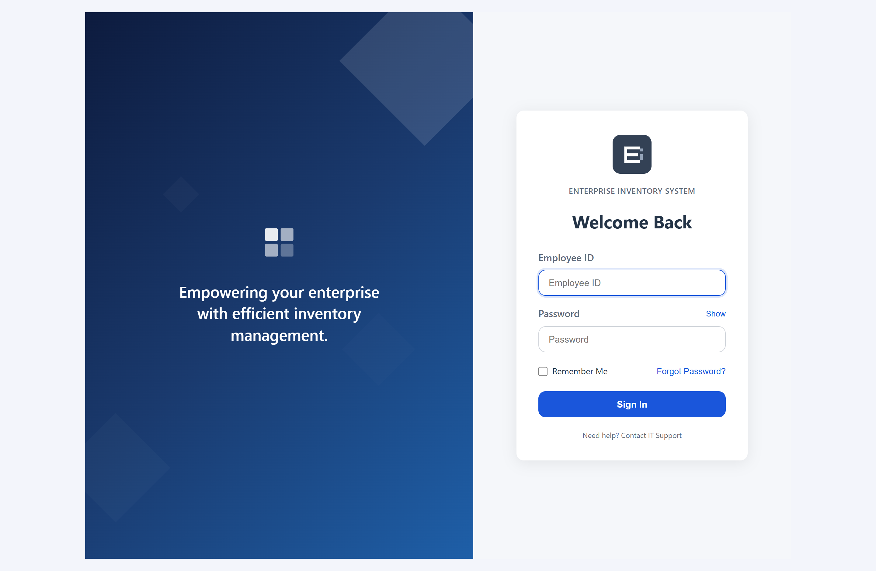
Figure E.1: Sign-in screen. Authentication is by employee number rather than name.
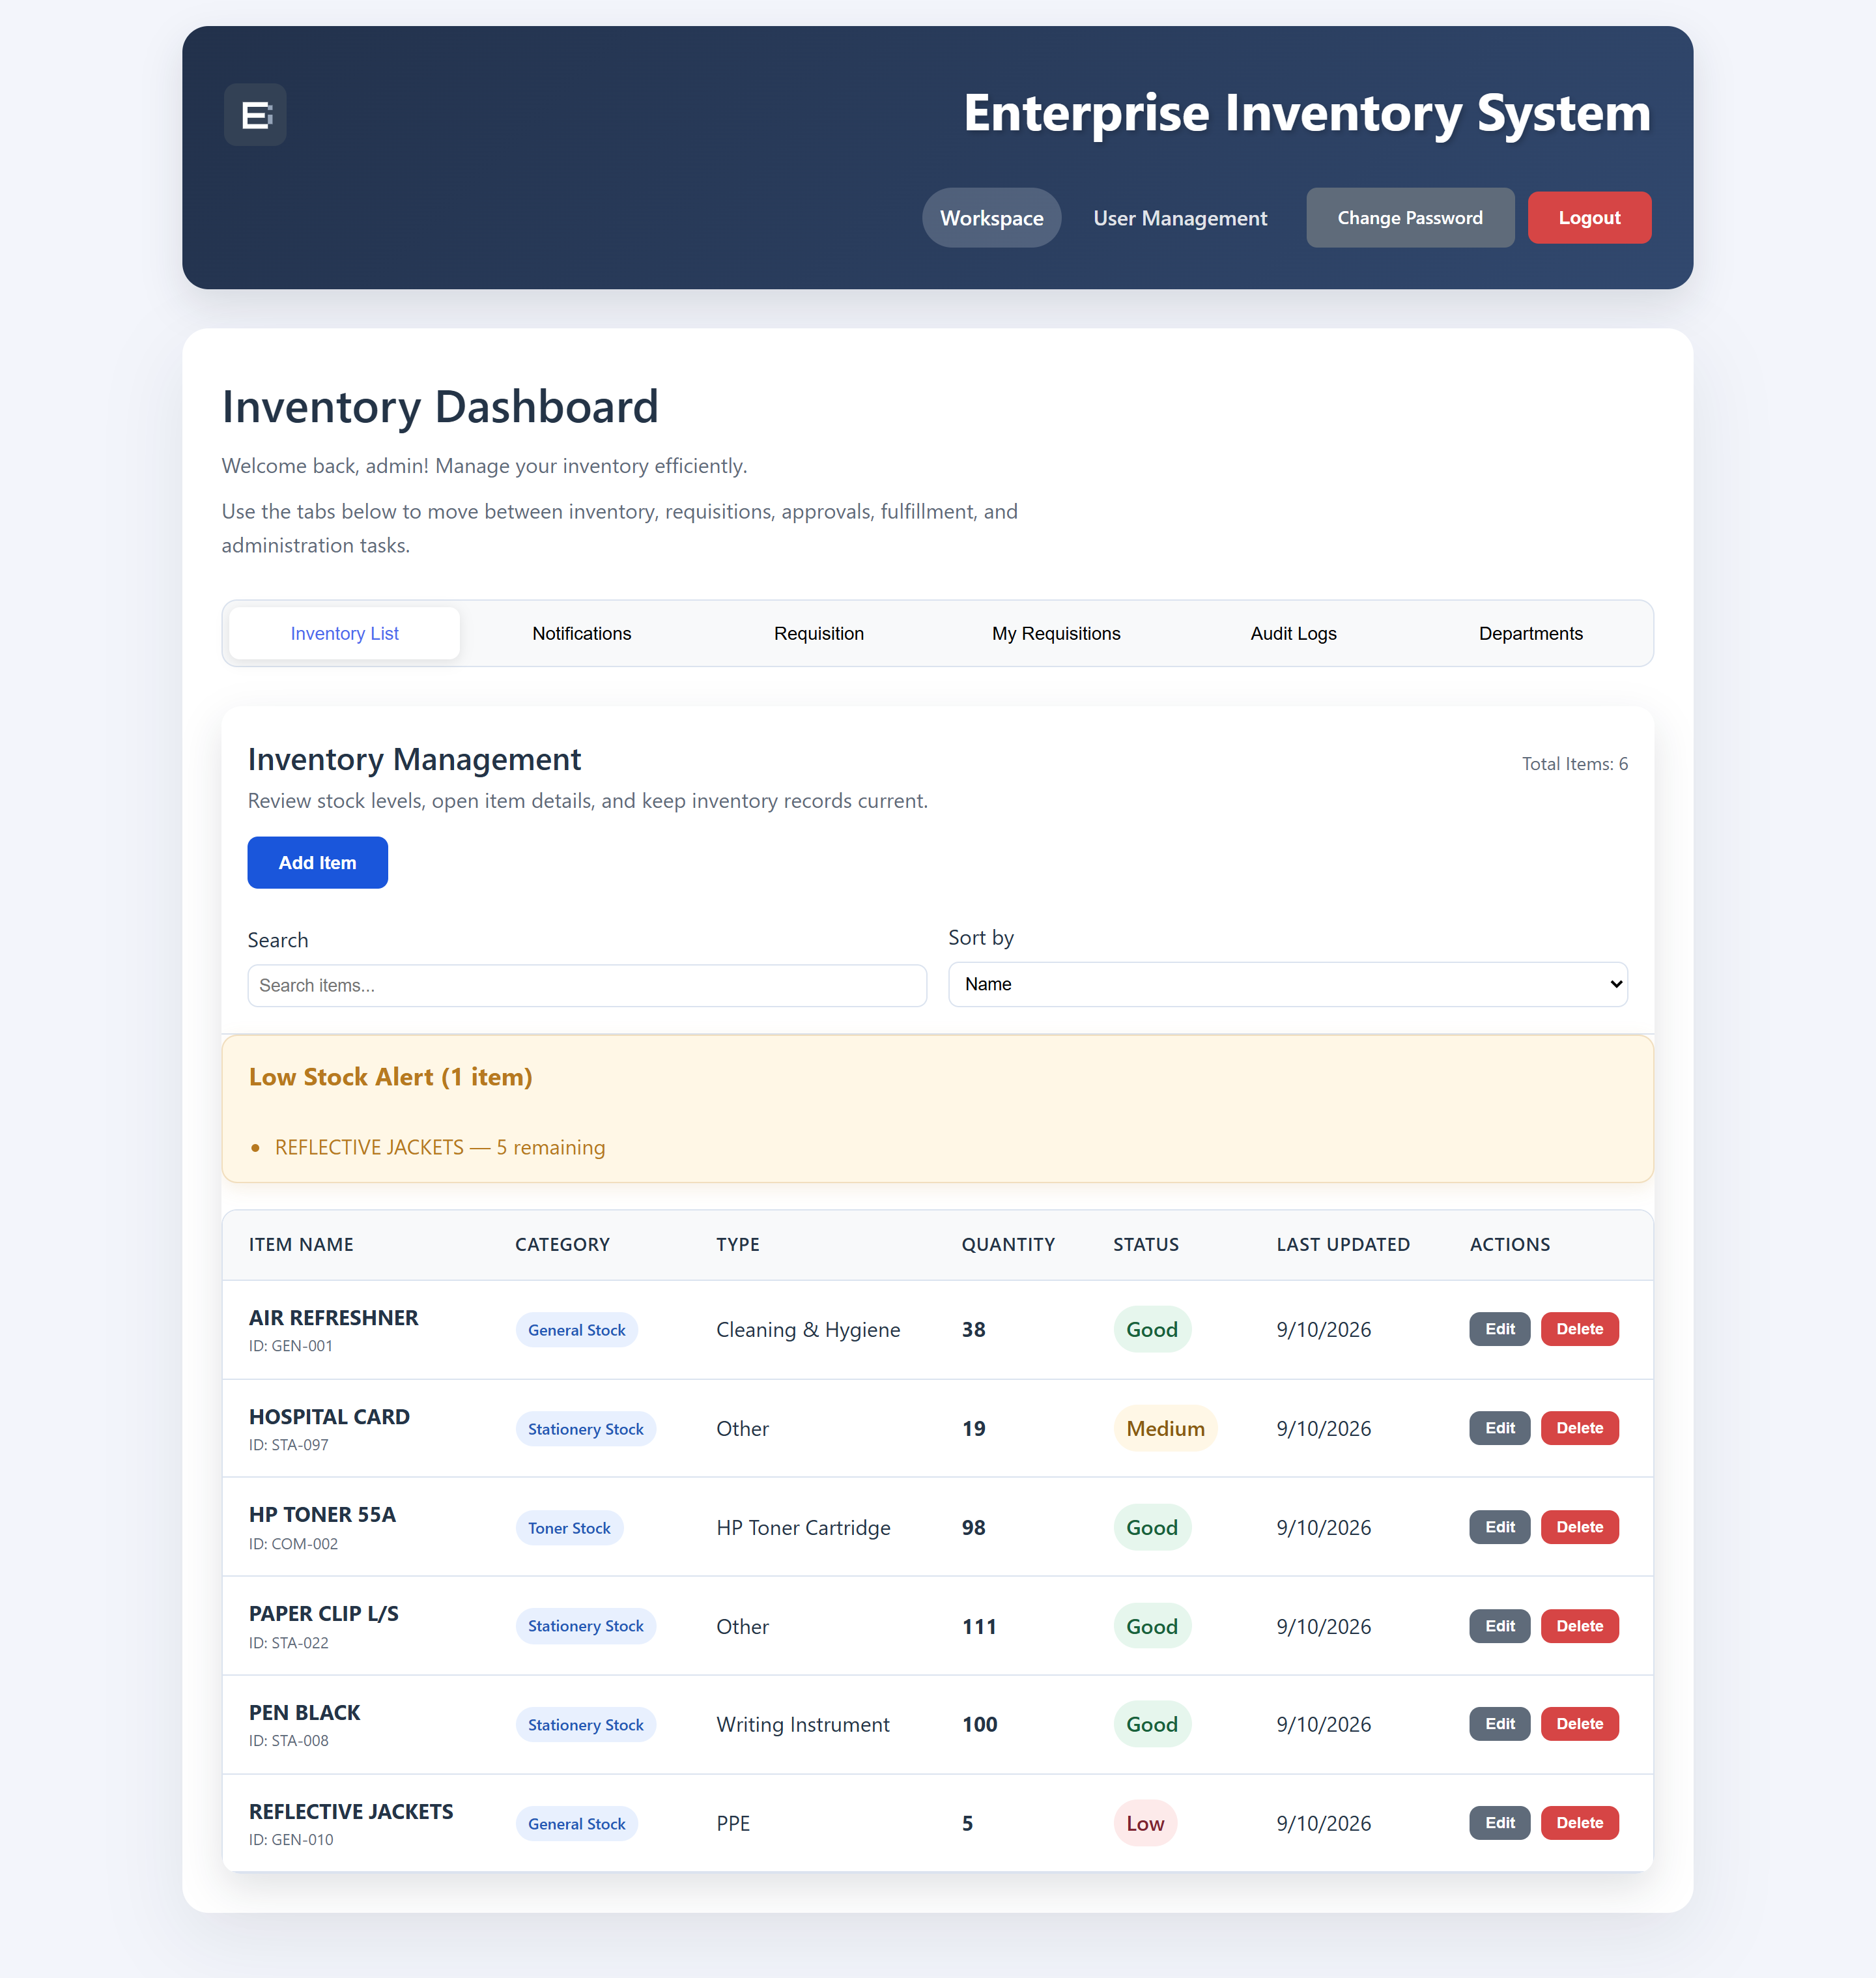
Figure E.2: Inventory dashboard, showing search, sorting, per-item status badges, the low-stock banner and the Last Updated column.
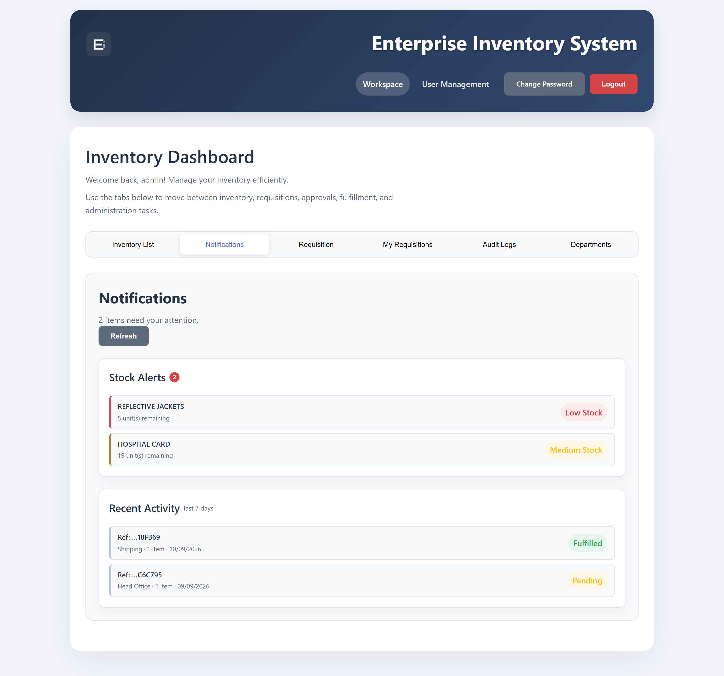
Figure E.3: Stock alerts, grouped by severity. An empty inventory is reported as untracked rather than as a clean bill of health.
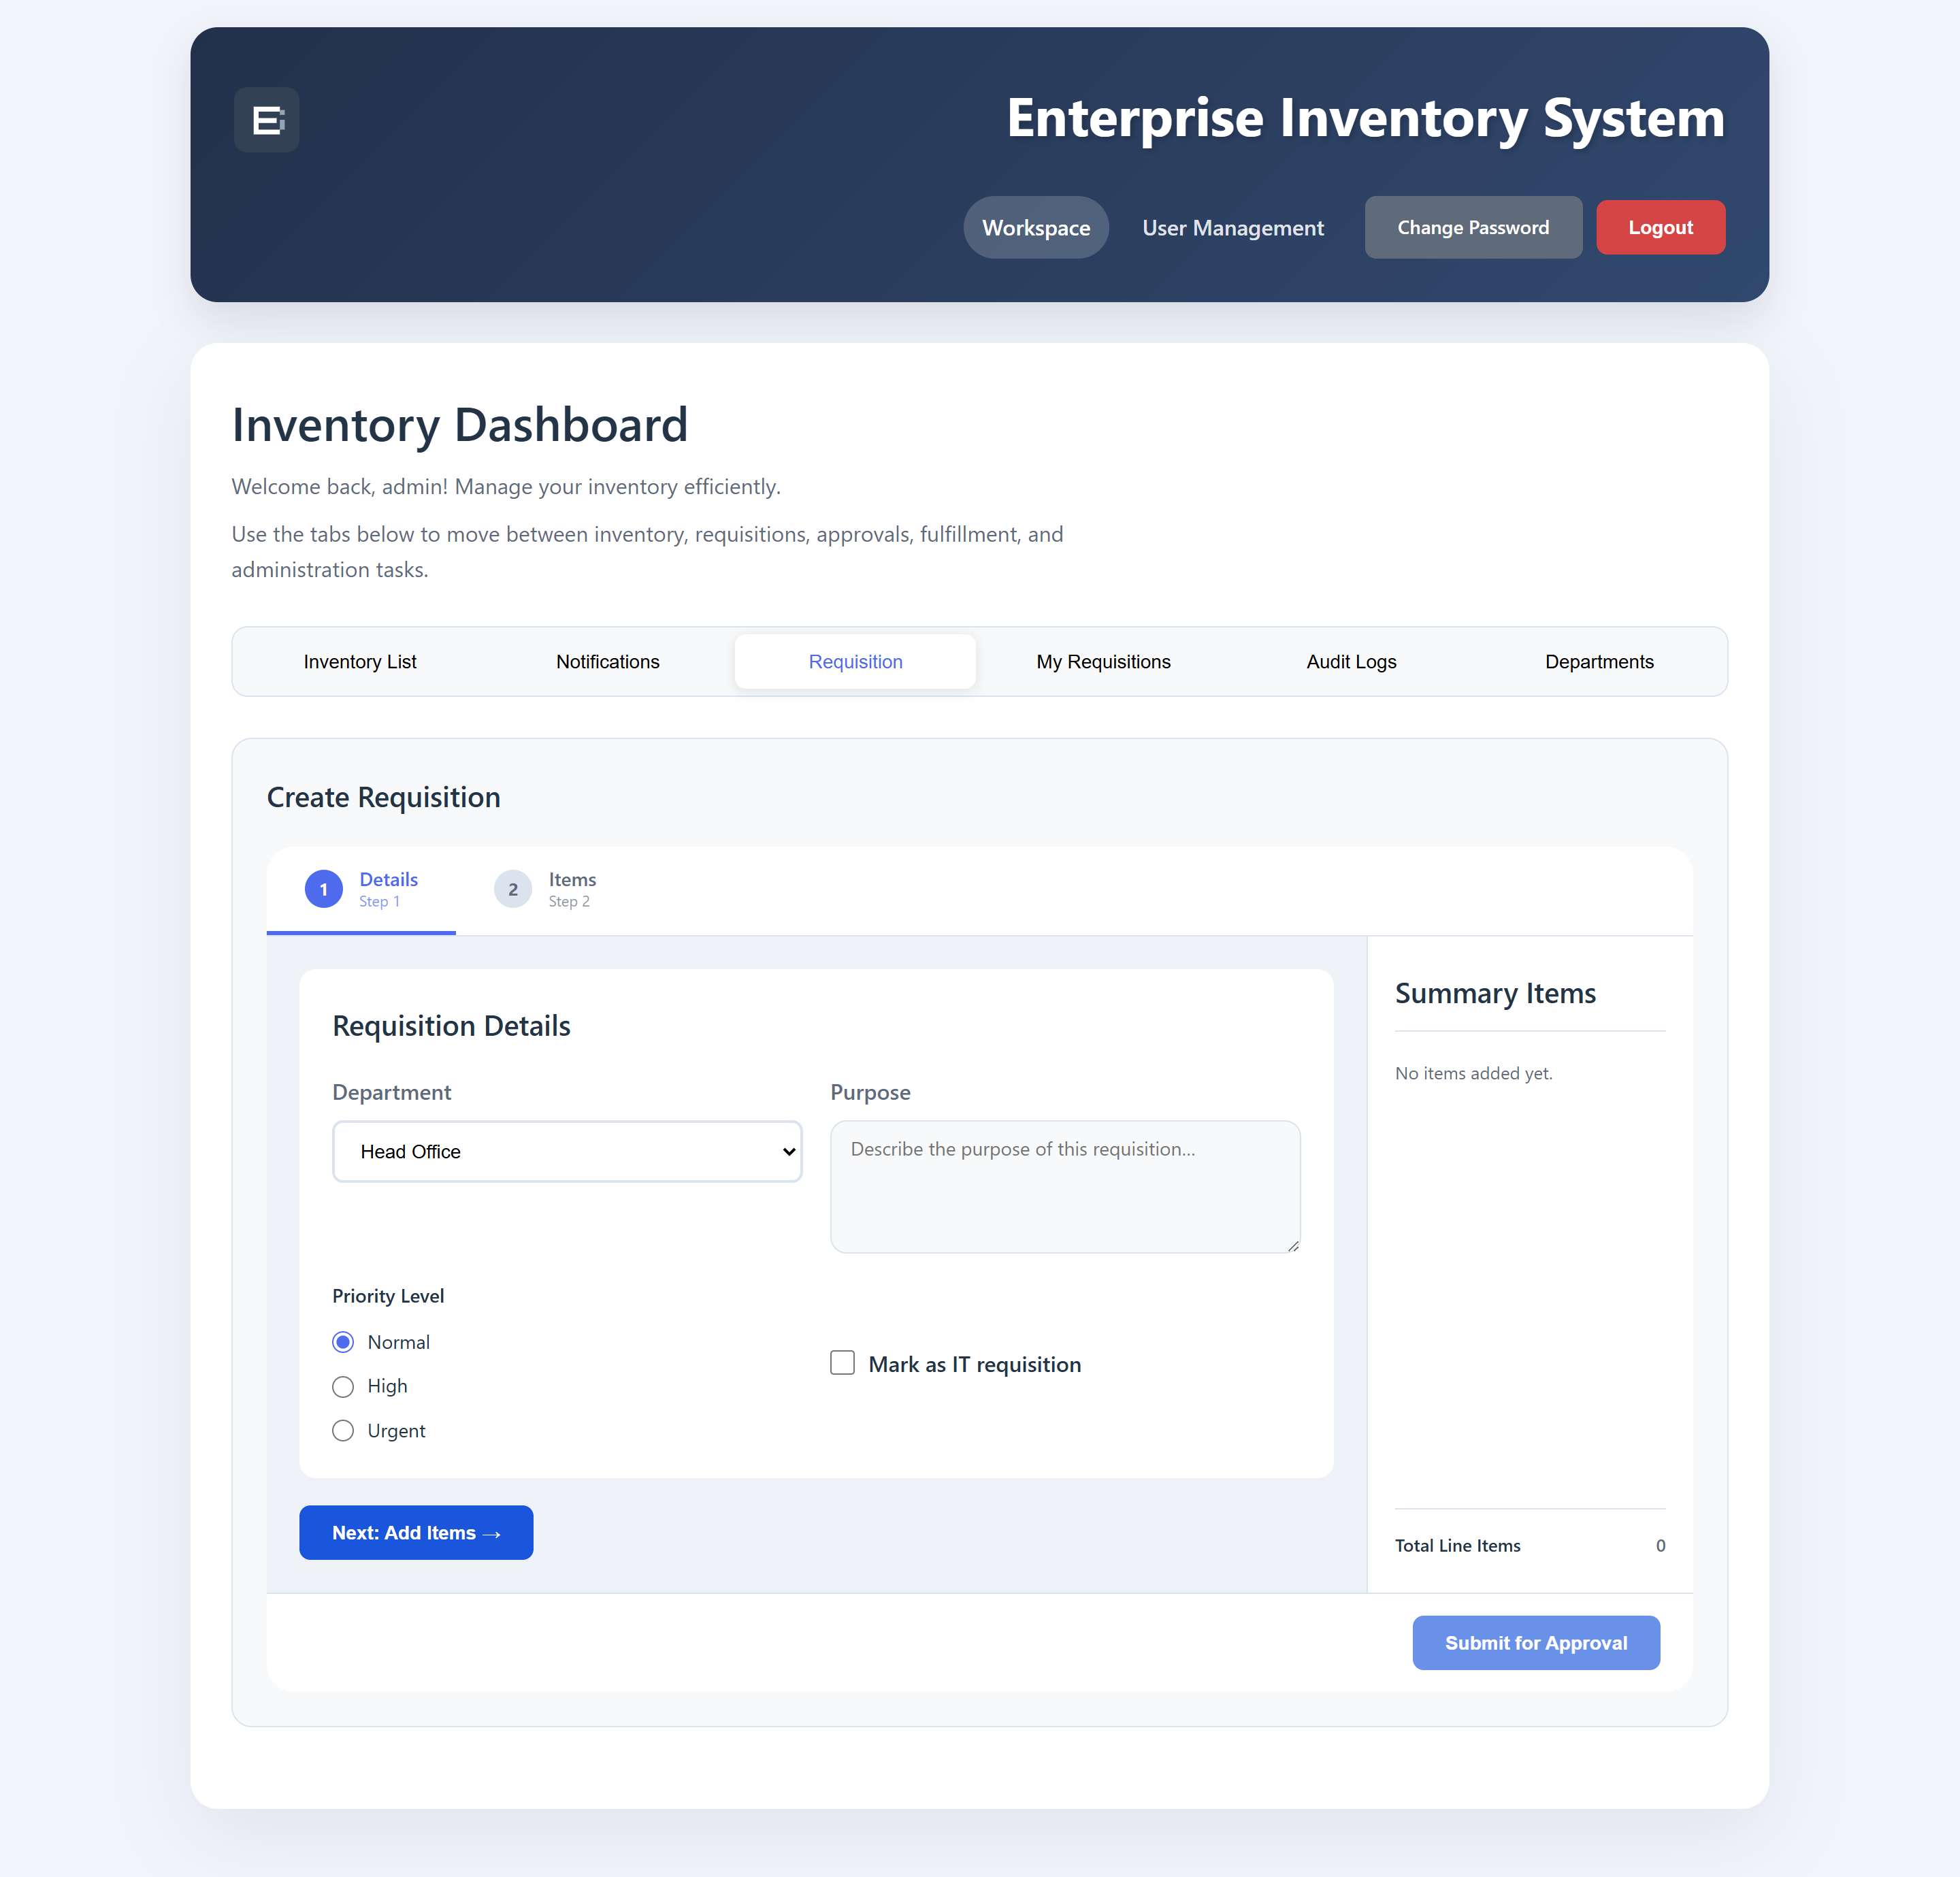
Figure E.4: Raising a requisition: step one of the two-step wizard, where department, purpose and priority are set.
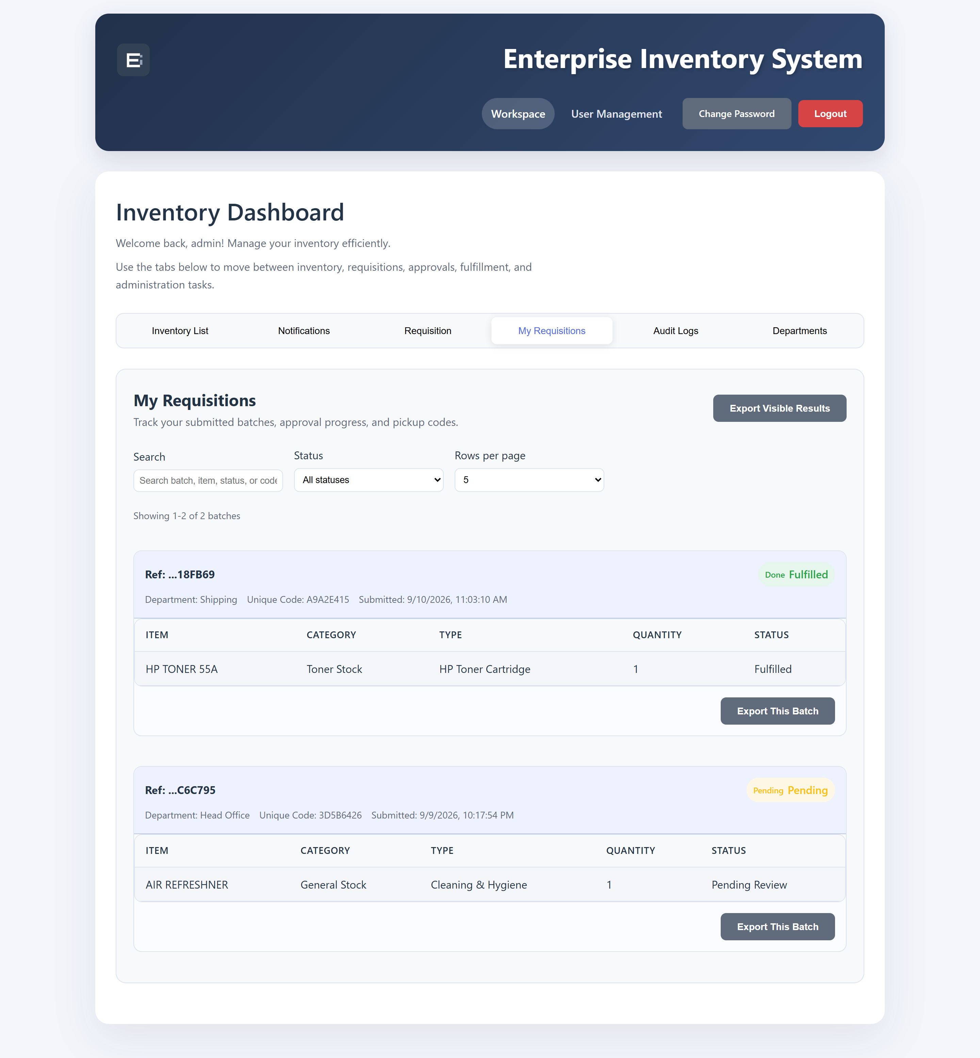
Figure E.5: My Requisitions. A requester sees their own batches and the stage each has reached.
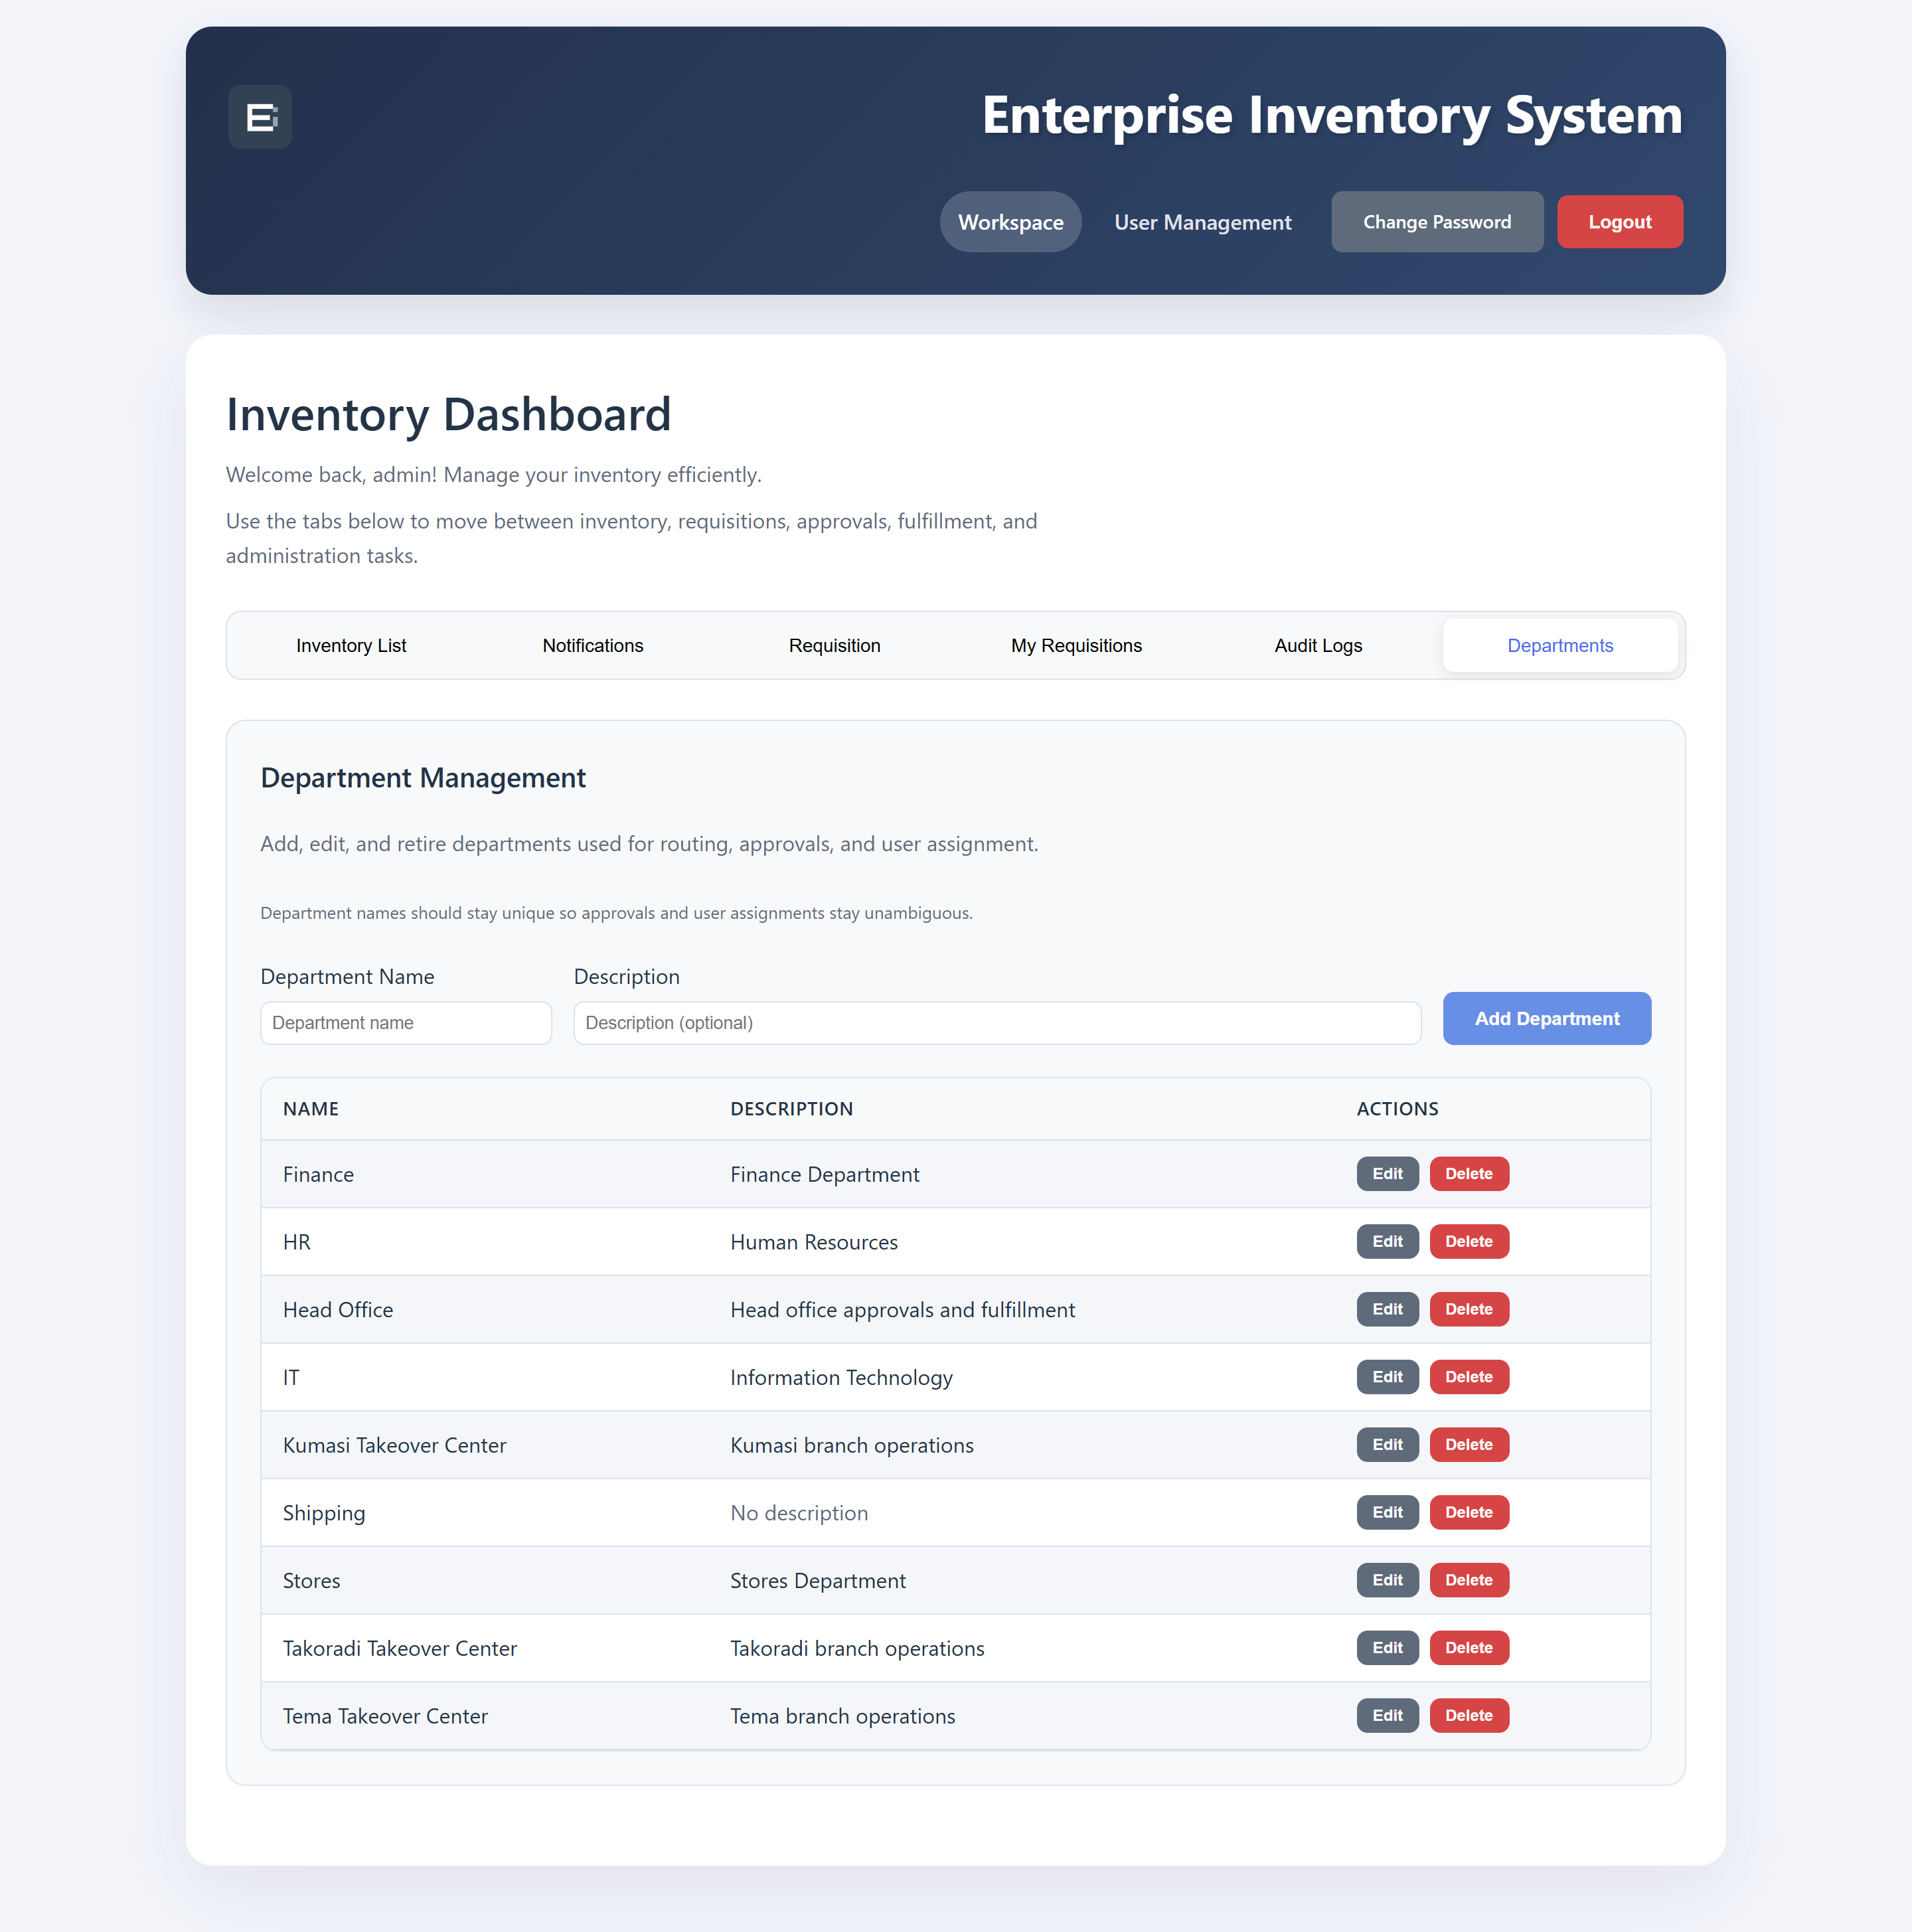
Figure E.6: Department management. The head-office flag recorded here selects the approval route for every requisition raised by the department.
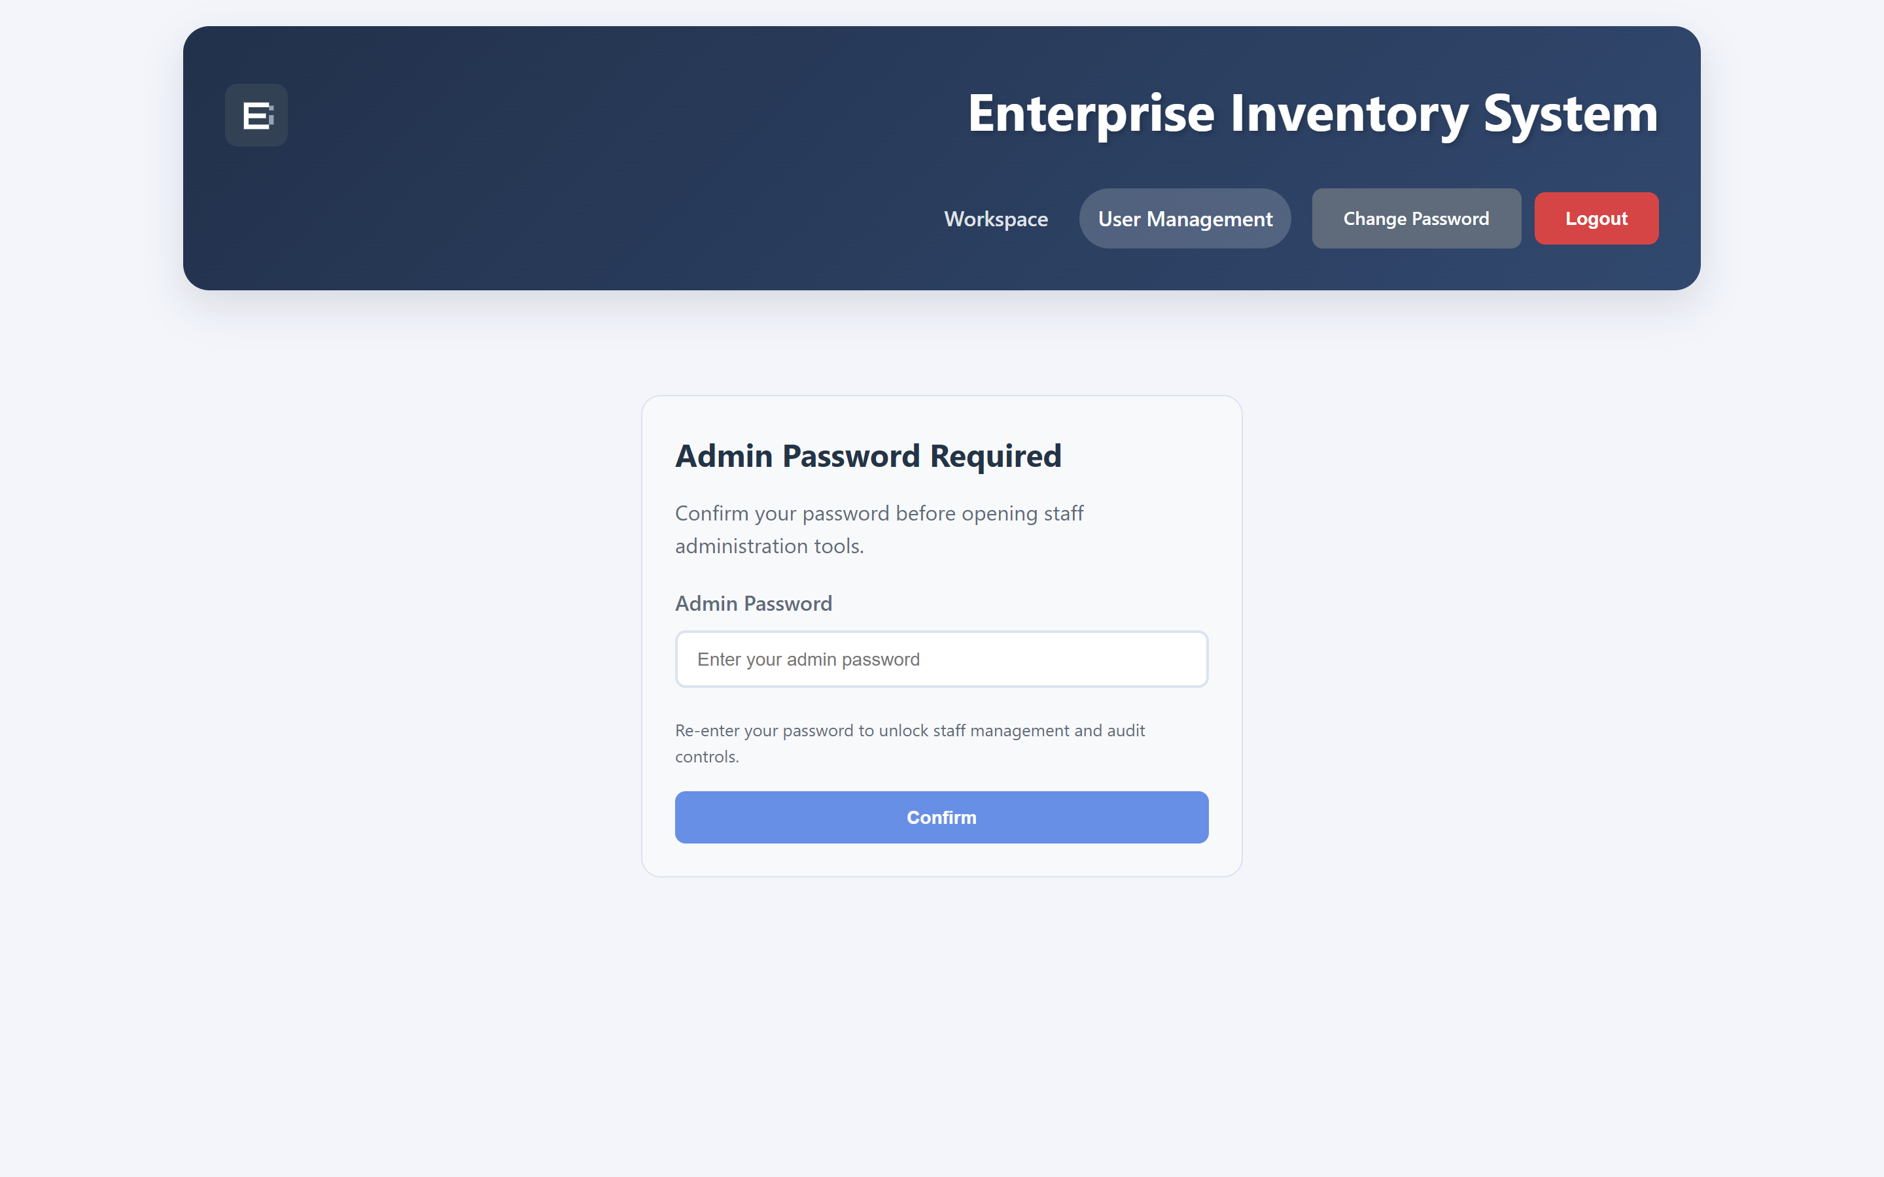
Figure E.7: User management. Administrators must re-enter their password before staff administration tools unlock.
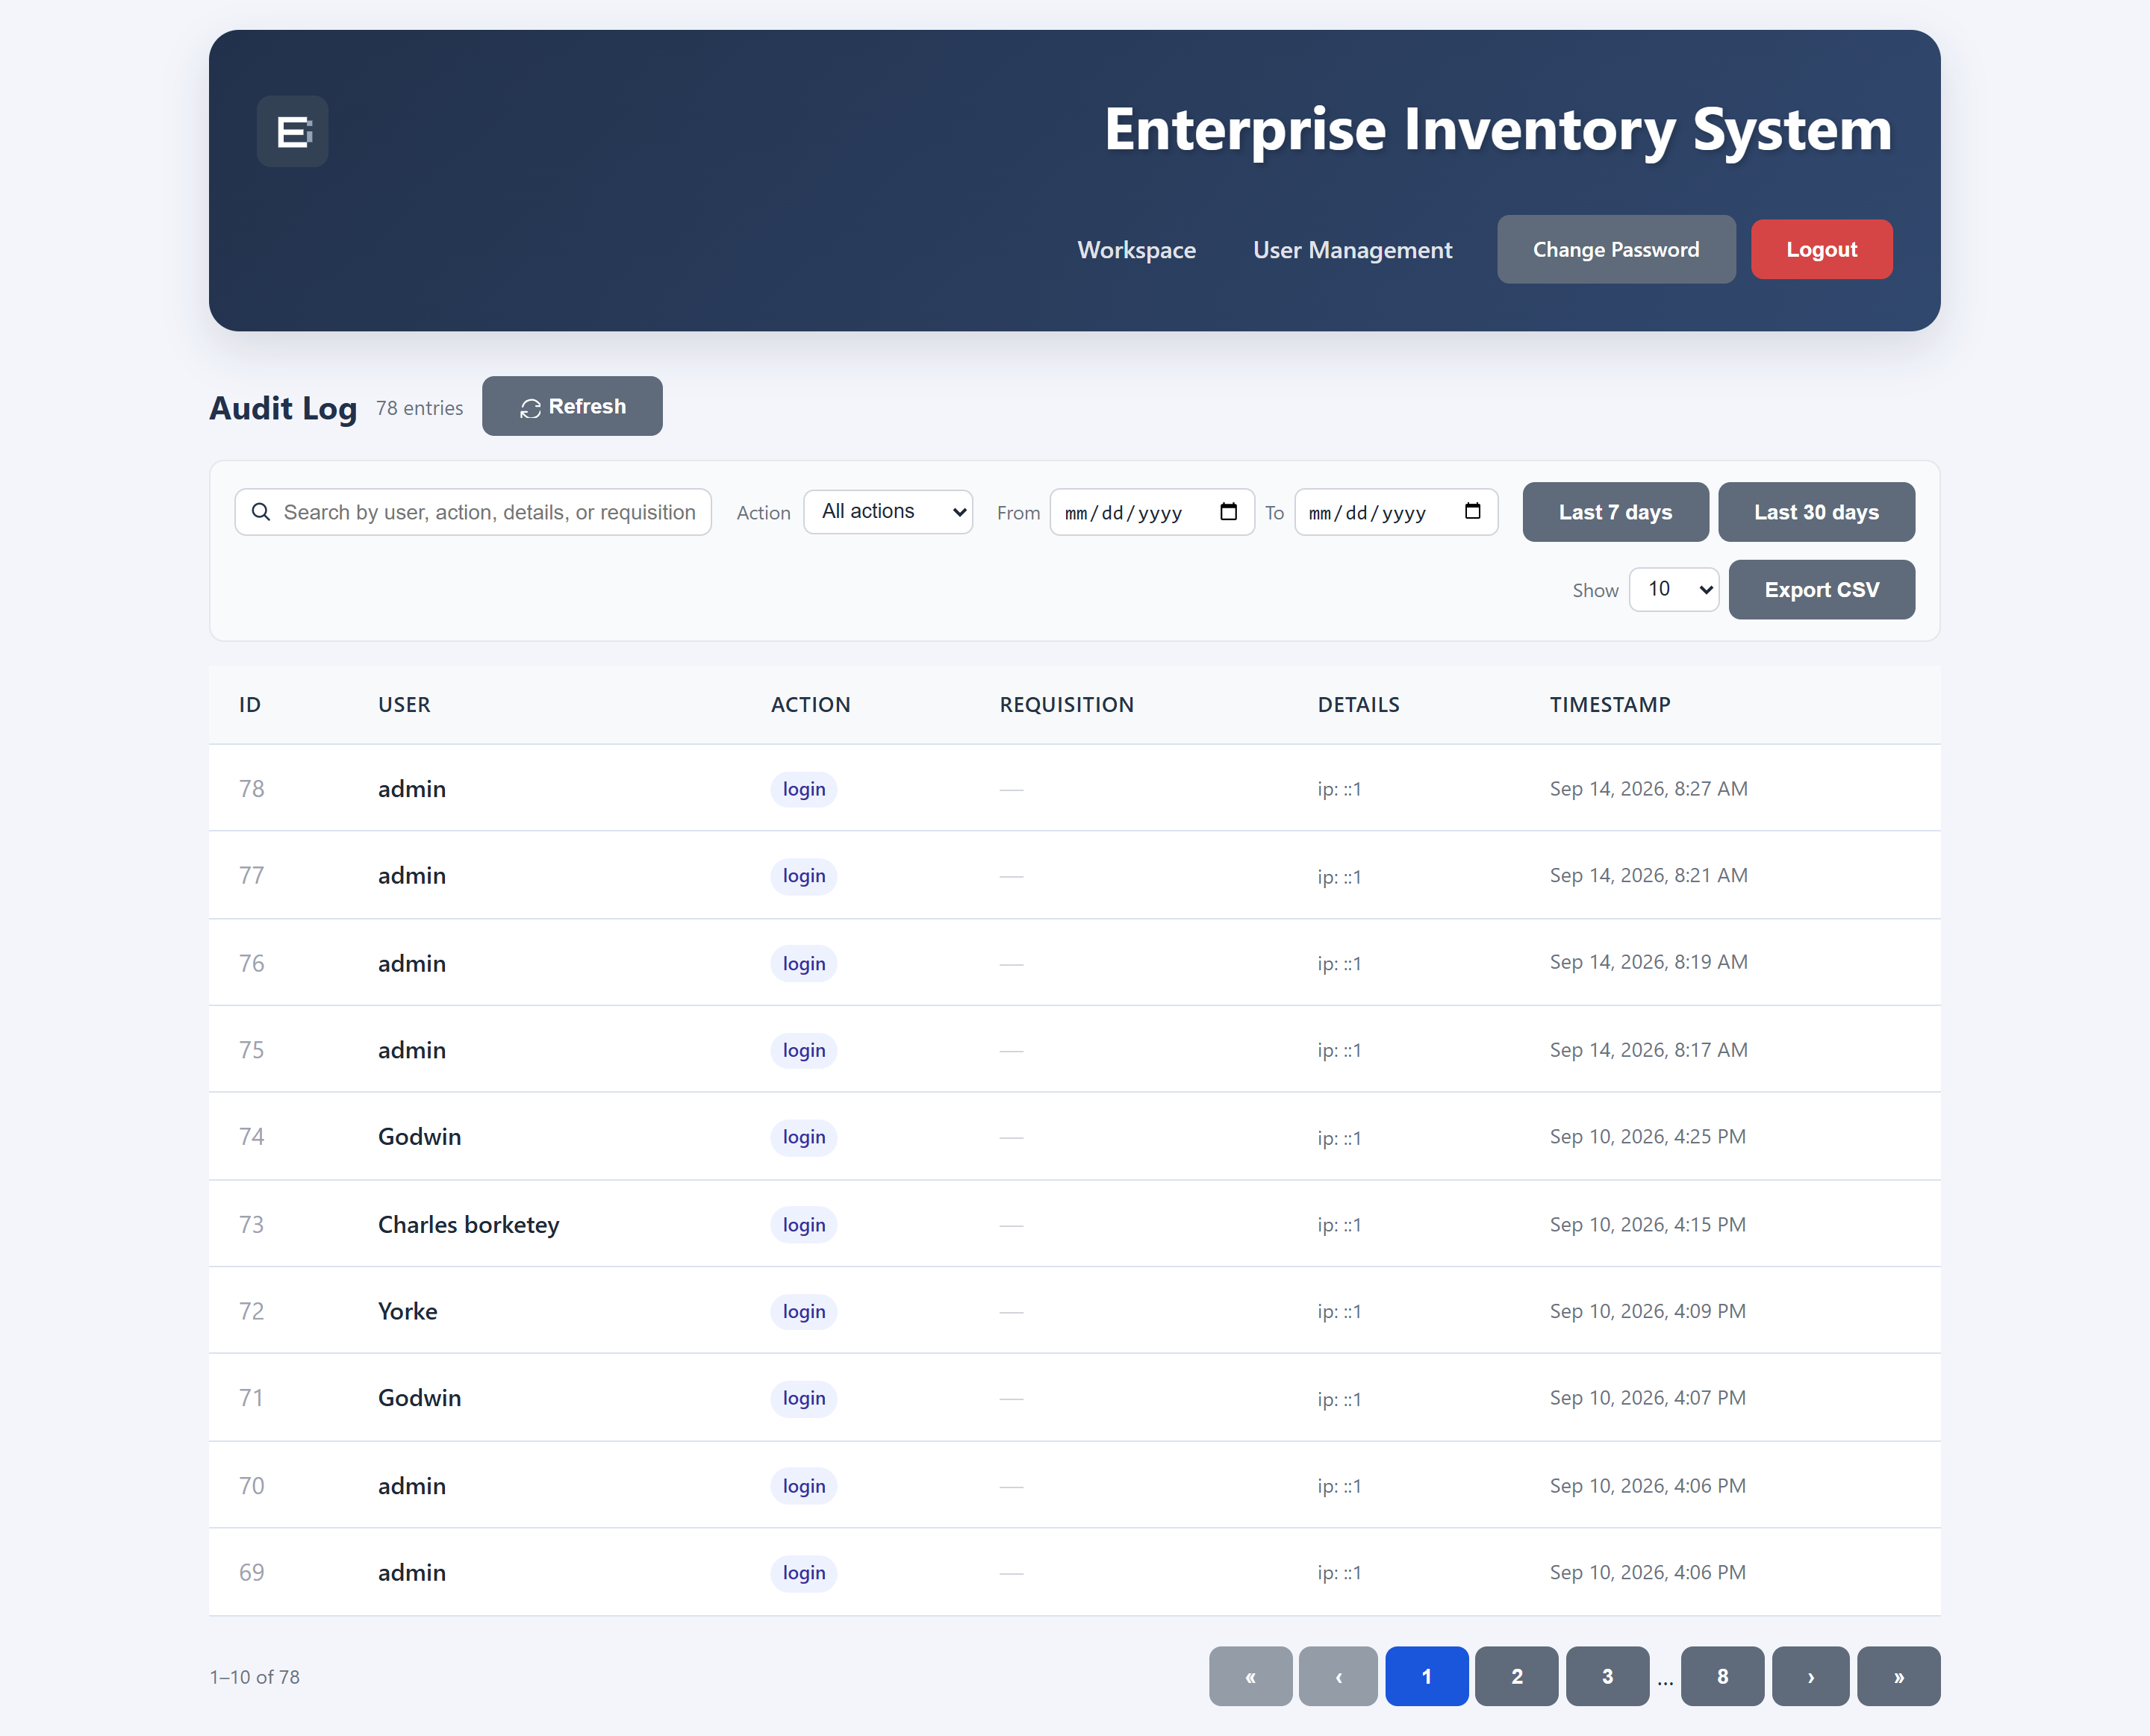
Figure E.8: Audit log, with filtering by user, action and date range, pagination and CSV export over the append-only trail.
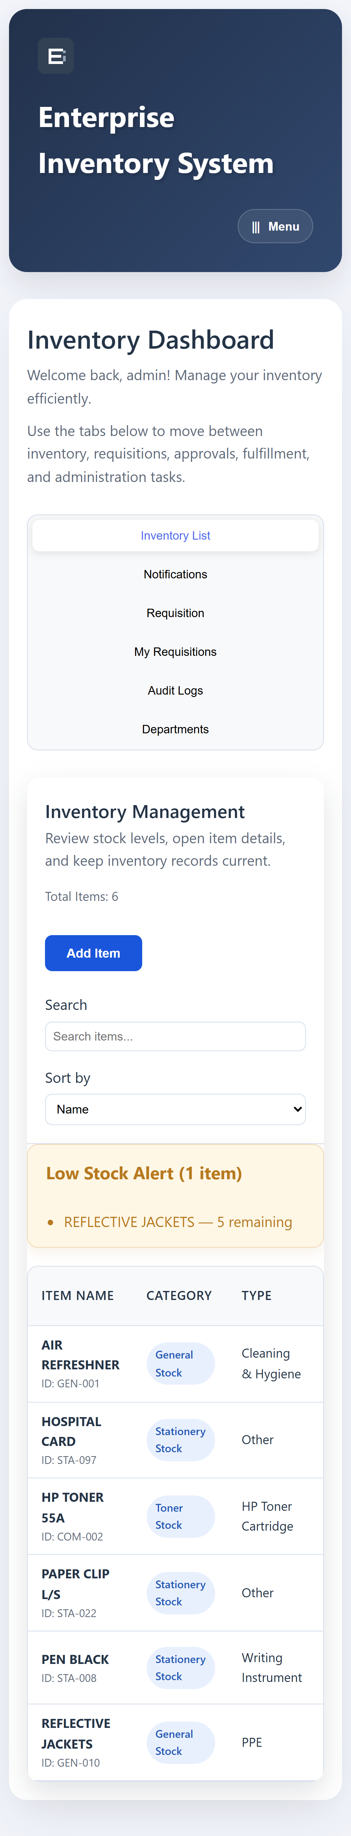
Figure E.9: The dashboard rendered at 390 px, the width of a typical mobile handset.
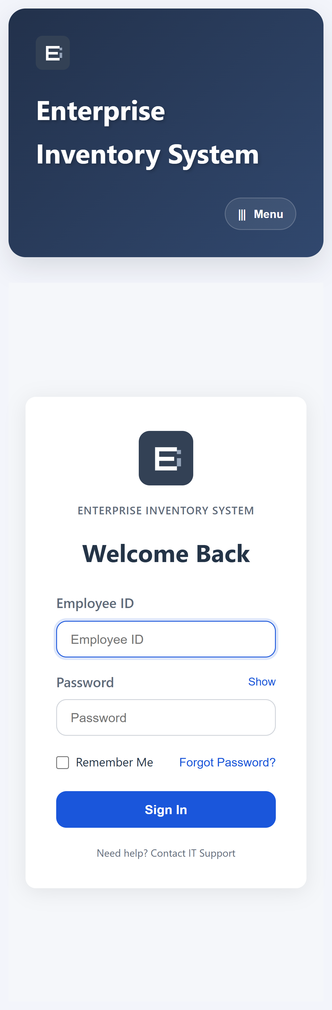
Figure E.10: The sign-in screen at 390 px.
Two interfaces are absent from this appendix. The Approvals and Fulfilment screens are restricted to approver and stores roles respectively, and are not rendered for an administrator session, so they could not be captured in the same automated pass. They are reachable by signing in as a holder of the relevant role.

REFERENCES
Banks, A., & Porcello, E. (2020). Learning React: Modern patterns for developing React apps (2nd ed.). O’Reilly Media.
Casciaro, M., & Mammino, L. (2020). Node.js design patterns (3rd ed.). Packt Publishing.
Chopra, S., & Meindl, P. (2019). Supply chain management: Strategy, planning, and operation (7th ed.). Pearson.
Dumas, M., La Rosa, M., Mendling, J., & Reijers, H. A. (2018). Fundamentals of business process management (2nd ed.). Springer.
Elmasri, R., & Navathe, S. B. (2016). Fundamentals of database systems (7th ed.). Pearson.
Ghana Cocoa Board. (2024). Cocoa Marketing Company (Ghana) Limited. https://cocobod.gh
Kleppmann, M. (2017). Designing data-intensive applications: The big ideas behind reliable, scalable, and maintainable systems. O’Reilly Media.
Laudon, K. C., & Laudon, J. P. (2020). Management information systems: Managing the digital firm (16th ed.). Pearson.
Newman, S. (2021). Building microservices: Designing fine-grained systems (2nd ed.). O’Reilly Media.
OWASP Foundation. (2021). OWASP Top 10: The ten most critical web application security risks. https://owasp.org/Top10/
The PostgreSQL Global Development Group. (2024). PostgreSQL 16 documentation. https://www.postgresql.org/docs/16/
Pressman, R. S., & Maxim, B. R. (2020). Software engineering: A practitioner’s approach (9th ed.). McGraw-Hill Education.
Richards, G. (2017). Warehouse management: A complete guide to improving efficiency and minimizing costs in the modern warehouse (3rd ed.). Kogan Page.
Silberschatz, A., Korth, H. F., & Sudarshan, S. (2020). Database system concepts (7th ed.). McGraw-Hill Education.
Sommerville, I. (2016). Software engineering (10th ed.). Pearson.
Stallings, W., & Brown, L. (2018). Computer security: Principles and practice (4th ed.). Pearson.
van der Aalst, W. M. P. (2016). Process mining: Data science in action (2nd ed.). Springer.
Wild, T. (2017). Best practice in inventory management (3rd ed.). Routledge.

